Enterprise Network Design, Implementation, and Security
for Masakhane Technologies

Prepared by:
Kabelo Solomon Maphalla
Diploma in Information and Communication Technology Specialising in
(Application Development)

Project Start Date:
2 May 2026

Tools Used:
Cisco Packet Tracer
Microsoft Word
Draw.io
Git
GitHub

Table of Contents
CHAPTER 1 3
1.2 Project Aim 3
1.3 Project Objectives 4
1.4 Project Scope 4
1.6 Project Assumptions 5
1.7 Project Constraints 5
CHAPTER 2 5
2.2 Business Description 6
2.3 Organisational Structure 6
2.4 Department Overview 6
2.5 Current Business Challenges 7
2.6 Future Business Growth 7
CHAPTER 3 7
Business Requirements 7
3.2 Business Requirements 8
3.3 Functional Requirements 8
3.4 Non-Functional Requirements 9
3.5 Business Drivers 9
3.6 User Requirements 10
CHAPTER 4 Network Requirements 11
4.2 User Requirements 12
4.3 Network Performance Requirements 12
4.4 Internet Requirements 13
4.5 Wired Network Requirements 13
4.6 Wireless Network Requirements 14
4.7 Network Security Requirements 14
4.8 Scalability Requirements 15
CHAPTER 5 Hardware Requirements 15
5.2 Office Layout 15
5.3 End-User Devices 16
5.4 Network Infrastructure Devices 16
5.5 Network Cabling 17
5.6 Wireless Infrastructure 17
5.7 Server Infrastructure 18
5.8 Hardware Selection Justification 18
CHAPTER 6 Network Design 18
6.2 Proposed Network Architecture 19
6.3 Department Network Allocation 19
6.4 Physical Network Topology 20
6.5 Logical Network Topology 21
6.6 IP Addressing Scheme 22
6.7 Routing Design 23
6.8 Network Services 24
6.9 Network Security Design 26
CHAPTER 7 Network Implementation and Configuration 27
7.2 Implementation Strategy 28
7.3 Preparing the Cisco Packet Tracer Environment 29
7.4 Physical Device Placement 30
7.5 Physical Network Connections 31
7.6 Basic Device Configuration 32
7.7 VLAN Configuration 35
7.8 Trunk Configuration 36
7.9 Inter-VLAN Routing Configuration 37
7.10 Enterprise Server Configuration 38
7.11 Wireless Network Configuration 41
7.12 Network Security Configuration 43
CHAPTER 8 Network Testing and Validation 47
8.2 Testing Objectives 47
8.3 Testing Methodology 47
8.4 Test Environment 48
8.5 Test Cases and Results 48
8.6 Test Results Analysis 51
CHAPTER 9 Conclusion and Recommendations 52
9.2 Project Conclusion 52
9.3 Recommendations 53
9.4 Final Remarks 54
REFERENCES 55
APPENDICES 56
APPENDIX A 56
Final Enterprise Network Topology 56
APPENDIX B 56
Final VLAN Configuration 56
APPENDIX C 58
APPENDIX D 61
DHCP Configuration Verification 61
APPENDIX E 64
Appendix F 67
Static IP Address Verification 67
Appendix G 68
Appendix H 69
Appendix I 71
Appendix J 86

Executive Summary
Masakhane Technologies (Pty) Ltd is a growing technology company that requires a modern, secure, and scalable enterprise network to support its daily business operations. As the organisation expands, its network infrastructure must provide reliable connectivity for employees, protect business information, and support future growth without requiring significant redesign.
This project presents the design and implementation of an enterprise network that supports approximately 40 employees across multiple departments. The proposed solution primarily uses wired Ethernet connectivity for employee workstations to ensure secure departmental VLAN separation, while wireless access points are deployed to provide enterprise wireless infrastructure and support future wireless expansion. The design incorporates departmental network segmentation using Virtual Local Area Networks (VLANs), structured IPv4 addressing, centralised network services, secure Internet access, network printers, enterprise server services, and multiple network security measures.
The project documentation describes the business requirements, network design, implementation strategy, testing procedures, and recommendations for the proposed solution. A Cisco Packet Tracer simulation was developed to demonstrate the practical implementation of the enterprise network and verify that the proposed design satisfies the identified technical and business requirements while supporting scalability, reliability, and secure communication.
CHAPTER 1
1.1 Introduction
Modern organisations rely heavily on computer networks to support communication, collaboration, access to business applications, and the sharing of information and resources. As businesses continue to grow and adopt new technologies, their network infrastructure must be designed to provide high availability, security, scalability, and reliable performance. A well-designed enterprise network enables organisations to operate efficiently while supporting future expansion and reducing the complexity of network management (Kurose and Ross, 2021; Cisco Systems, n.d.).
Masakhane Technologies (Pty) Ltd is a growing technology company that requires a modern enterprise network capable of supporting approximately 40 employees across multiple departments. The proposed network will provide secure wired and wireless connectivity, efficient communication between departments, centralised network services, and secure Internet access. The design will follow recognised enterprise networking principles, including a hierarchical architecture, structured IP addressing, and logical network segmentation through Virtual Local Area Networks (VLANs), to improve performance, simplify administration, and accommodate future business growth (Cisco Systems, n.d.; Tanenbaum and Wetherall, 2021).

1.2 Project Aim
This project aims to design, implement, and document a secure, scalable, and reliable enterprise network for Masakhane Technologies (Pty) Ltd. The project also aims to demonstrate practical networking skills by implementing the proposed design in Cisco Packet Tracer while following recognised enterprise networking best practices.

1.3 Project Objectives
The objectives of this project are to:
- Design a secure and scalable enterprise network for Masakhane Technologies (Pty) Ltd.
- Implement a hierarchical network architecture suitable for a small-to-medium-sized enterprise.
- Create separate VLANs for each department to improve network performance and security.
- Develop an organised IPv4 addressing plan for all network devices.
- Provide reliable wired and wireless network connectivity for employees and guests.
- Incorporate network security measures to protect organisational resources.
- Simulate and test the network using Cisco Packet Tracer.
- Produce professional technical documentation that reflects industry best practices.

1.4 Project Scope
This project focuses on the design and planned implementation of an enterprise network for Masakhane Technologies (Pty) Ltd. The scope includes business and technical requirements analysis, hardware and software selection, network topology design, IP addressing, VLAN implementation, routing, wireless networking, network security, testing procedures, and technical documentation. Although the network will be implemented in Cisco Packet Tracer, the design follows widely accepted enterprise networking principles used in real-world organisational environments (Cisco Systems, n.d.; West, Dean and Andrews, 2023).

1.5 Project Deliverables
The following deliverables will be produced during this project:
- A professionally documented enterprise network design report.
- A complete Cisco Packet Tracer simulation of the proposed network.
- Network topology diagrams.
- IP addressing and VLAN allocation tables.
- Testing and validation results.
- A GitHub repository containing the project documentation, Packet Tracer file, screenshots, and supporting files.

1.6 Project Assumptions
The project is based on the following assumptions:
- Masakhane Technologies currently operates from a single office location.
- The company employs approximately 40 staff members.
- Reliable Internet connectivity is available from an Internet Service Provider (ISP).
- Employees primarily use wired Ethernet connections to ensure secure departmental VLAN separation. Wireless access points are deployed to provide enterprise wireless infrastructure and support future wireless expansion.
- The organisation expects future growth, requiring the network to be scalable.
- Cisco networking devices are used for the network implementation and simulation.

1.7 Project Constraints
The project is subject to the following constraints:
- The implementation will be simulated using Cisco Packet Tracer rather than deployed on physical equipment.
- Budget considerations have been considered when selecting network equipment.
- The project is designed for educational and portfolio purposes while following enterprise networking practices.
- The design assumes standard office networking requirements and does not include multiple branch offices.

CHAPTER 2
2.1 Company Background
Masakhane Technologies (Pty) Ltd is a fictional small-to-medium-sized information technology company created for the purpose of this enterprise network design project. The company provides IT support, network installation, technical consulting, infrastructure maintenance, and managed technology services to business clients.
As the organisation continues to grow, it requires a reliable and secure network infrastructure that supports communication between employees, enables access to business applications, and protects organisational data. The proposed network has been designed to meet the company's current operational requirements while providing sufficient capacity to support future expansion.

2.2 Business Description
Masakhane Technologies specialises in delivering technology solutions to small and medium-sized businesses. The company assists clients with computer hardware installation, network deployment, technical support, system maintenance, troubleshooting, and infrastructure upgrades.
The company also provides network monitoring, user support, equipment maintenance, and consulting services to ensure that clients' IT environments operate efficiently and securely. To deliver these services effectively, employees require continuous access to internal resources, shared files, cloud-based applications, and reliable Internet connectivity.

2.3 Organisational Structure
Masakhane Technologies operates through several departments, each responsible for specific business functions. These departments work together to ensure efficient service delivery while maintaining clear responsibilities and communication channels.
The organisation is structured into the following departments:
- Management
- Reception
- Human Resources
- Finance
- Sales
- Information Technology (IT)
Each department has different networking requirements based on its daily activities and the applications it uses.

2.4 Department Overview
The responsibilities of each department are summarised below.
Department | Primary Responsibility
Management | Strategic planning, decision-making, and business operations.
Reception | Welcoming visitors, answering enquiries, and providing administrative support.
Human Resources | Employee records, recruitment, payroll coordination, and staff administration.
Finance | Financial reporting, budgeting, invoicing, and accounting activities
Sales | Customer engagement, quotations, marketing support, and business development.
Information Technology | Technical support, network administration, cybersecurity, infrastructure maintenance, and system monitoring.

2.5 Current Business Challenges
To support its continued growth, Masakhane Technologies requires improvements to its network infrastructure. The organisation has identified the following business and technical challenges that the proposed network must address:
- The need for reliable communication between departments.
- Secure access to organisational data and services.
- Improved wireless connectivity throughout the office.
- Network scalability to accommodate future employees and devices.
- Enhanced protection against unauthorised access.
- Simplified network management and troubleshooting.
- High network availability to minimise downtime.
These challenges form the basis for the enterprise network design proposed in this report.

2.6 Future Business Growth
Masakhane Technologies expects to expand its operations over the coming years. The organisation plans to increase its workforce, introduce additional business services, and invest in new technologies to improve operational efficiency.
To support this growth, the proposed network has been designed with scalability in mind. The network architecture allows additional users, departments, wireless access points, servers, and network devices to be added without requiring a complete redesign of the existing infrastructure.
The scalable design ensures that the organisation can continue to meet future business requirements while maintaining reliable performance, effective security, and simplified network management.

CHAPTER 3
Business Requirements
3.1 Introduction
Business requirements define what an organisation expects to achieve through the implementation of a new network infrastructure. Before selecting networking equipment or designing the network, it is important to understand the operational needs of the business. These requirements ensure that the proposed solution aligns with the organisation's objectives and supports both current operations and future growth.
For Masakhane Technologies (Pty) Ltd, the enterprise network has been designed to improve communication, enhance security, increase productivity, and provide a reliable technology platform that supports business operations.

3.2 Business Requirements
To support its daily operations and future expansion, Masakhane Technologies has identified the following business requirements:
- Reliable communication between all departments.
- Secure access to organisational resources.
- High-speed Internet connectivity.
- Secure wired network access for employee workstations, supported by enterprise wireless infrastructure and a dedicated guest wireless network.
- Centralised management of network devices.
- Reliable access to shared printers and file storage.
- A scalable network capable of supporting future growth.
- Improved network availability to minimise downtime.
- Secure remote management of network infrastructure.
- Protection of business information from unauthorised access.
These requirements form the foundation of the proposed enterprise network design.

3.3 Functional Requirements
Functional requirements describe the specific services and capabilities that the network must provide to support the organisation's daily operations. These requirements define what the network must do to meet business needs (West, Dean and Andrews, 2023).
The proposed network must provide the following functions:
- Provide Internet access for authorised users.
- Connect all employee laptops and authorised network devices.
- Support secure wired connectivity for employee workstations while providing enterprise wireless infrastructure for guest access and future expansion.
- Automatically assign IP addresses using DHCP.
- Enable communication between departments where authorised.
- Provide secure access to shared network resources.
- Support network printing services.
- Allow network administrators to monitor and manage network devices.
- Provide secure guest wireless access for visitors.

3.4 Non-Functional Requirements
Non-functional requirements define the quality characteristics that the network should achieve. These requirements focus on performance, security, reliability, maintainability, and scalability rather than specific network functions (Kurose and Ross, 2021).
The proposed network should:
- Provide high availability during business hours.
- Deliver reliable network performance.
- Support future business growth.
- Be easy to maintain and troubleshoot.
- Protect organisational information through appropriate security controls.
- Minimise network downtime.
- Allow future integration with additional technologies.
- Support efficient management of network resources.

3.5 Business Drivers
Several business factors have influenced the decision to implement a new enterprise network.
The primary business drivers include:
- Business expansion.
- Increasing number of employees.
- Growing dependence on digital technologies.
- Improved collaboration between departments.
- Increased cybersecurity awareness.
- Better customer service.
- Improved operational efficiency.
- Reduced downtime.
- Support for future cloud-based services.
These drivers demonstrate the importance of investing in a modern network infrastructure that supports both current and future organisational requirements.

3.6 User Requirements
Different departments within Masakhane Technologies require network access based on their daily responsibilities. To support a modern working environment, every employee is issued with a company-owned business laptop and an external monitor. Employee workstations connect to the enterprise network through secure wired Ethernet connections to ensure reliable performance and maintain departmental VLAN separation. Wireless access points are deployed throughout the organisation to provide enterprise wireless infrastructure, support the dedicated guest wireless network, and accommodate future wireless expansion. This approach provides reliable connectivity while maintaining network security and scalability.
Management
- Company-issued business laptop.
- External monitor.
- Secure access to business reports and confidential information.
- Reliable, wired network connectivity.
- Secure Internet access.
Reception
- Company-issued business laptop.
- External monitor.
- Access to visitor management systems.
- Email communication.
- Internet access.
Human Resources
- Company-issued business laptop.
- External monitor.
- Secure access to employee records.
- File sharing.
- Network printing.
Finance
- Company-issued business laptop.
- External monitor.
- Secure access to financial applications.
- Access to shared printers.
- Secure storage of financial information.
Sales
- Company-issued business laptop.
- External monitor.
- Access to Customer Relationship Management (CRM) systems.
- Reliable Internet access.
- Access to enterprise network resources.
Information Technology
- Company-issued business laptop.
- Two external monitors.
- Administrative access to network devices.
- Access to enterprise servers.
- Network monitoring software.
- Troubleshooting and management tools.
3.7 Business Success Criteria
The project will be considered successful if the following objectives are achieved:
- All departments have reliable network connectivity.
- Employees can securely access required business resources.
- Wired network services operate reliably, while enterprise wireless infrastructure successfully supports guest connectivity and future wireless expansion.
- VLAN segmentation improves network organisation and security.
- The network supports future business growth.
- Internet connectivity is stable and reliable.
- Network devices are centrally managed.
- The Cisco Packet Tracer implementation successfully demonstrates the proposed enterprise network design.

CHAPTER 4
Network Requirements
4.1 Introduction
A successful enterprise network begins with a clear understanding of the organisation's technical requirements. Network requirements define the infrastructure, services, and technologies needed to support business operations while ensuring the network remains secure, reliable, scalable, and easy to manage. Identifying these requirements before implementation helps ensure that the final network design meets both current and future organisational needs (Kurose and Ross, 2021; Cisco Systems, n.d.).

4.2 User Requirements
The proposed enterprise network will support approximately 40 employees working across multiple departments. Every employee will be provided with a company-issued business laptop and an external monitor to support daily business activities. Employee workstations will primarily connect to the enterprise network through secure wired Ethernet connections to ensure reliable performance, consistent connectivity, and proper departmental VLAN separation. Wireless access points will provide enterprise wireless infrastructure, support the dedicated guest wireless network, and accommodate future wireless expansion.
The network must provide:
- High-speed Internet access.
- Reliable, wired Ethernet connectivity for employee workstations.
- Enterprise wireless infrastructure for guest access and future expansion.
- Access to shared printers and network resources.
- Secure communication between authorised departments.
- Reliable access to company servers.
- Secure authentication for all users.
- Continuous network availability during business hours.

4.3 Network Performance Requirements
To ensure efficient business operations, the proposed network must deliver consistent performance under normal operating conditions. Enterprise networks should provide sufficient bandwidth, low latency, high availability, and reliable connectivity to support business applications and communication services (Cisco Systems, n.d.; Kurose and Ross, 2021).
The network should therefore:
- Provide stable network connectivity.
- Minimise network congestion.
- Reduce broadcast traffic through VLAN implementation.
- Support simultaneous access by multiple users.
- Deliver reliable communication between departments.
- Maintain acceptable response times for business applications.

4.4 Internet Requirements
Masakhane Technologies requires continuous Internet connectivity to support daily business activities.
Internet services will be used for:
- Email communication.
- Cloud-based applications.
- Software updates.
- Video conferencing.
- Web browsing.
- Remote technical support.
- Online collaboration tools.
- Business research.
The Internet connection should remain available throughout business hours to minimise disruptions to organisational operations.

4.5 Wired Network Requirements
The wired network forms the foundation of the proposed enterprise infrastructure by providing reliable, high-speed, and secure connectivity for employee workstations and critical network devices. Wired Ethernet connections offer greater bandwidth, lower latency, and improved reliability compared to wireless connectivity, making them ideal for supporting daily business operations.
The wired network will use Category 6 (Cat6) Ethernet cabling to connect enterprise devices throughout the organisation.
The wired network will support the following devices:
- Employee laptops.
- Enterprise server.
- Network printers.
- Access switches.
- Layer 3 Core Switch.
- Edge router.
- Firewall.
- Wireless access points.
This design provides reliable connectivity for all employee workstations while ensuring that critical infrastructure devices operate efficiently and securely.

4.6 Wireless Network Requirements
Wireless networking provides mobility by allowing authorised users and visitors to connect compatible devices without requiring physical network cables. In enterprise environments, wireless networks should provide secure authentication, adequate coverage, and sufficient capacity while protecting corporate resources from unauthorised access (Cisco Systems, n.d.).
Masakhane Technologies will implement two separate wireless networks.
Corporate Wireless Infrastructure
- Supports enterprise wireless services.
- Provides future expansion capabilities.
- Supports authorised wireless devices where required.
- Protected using enterprise wireless security.
Guest Wi-Fi
- Available only to visitors.
- Provides Internet access only.
- Completely isolated from the corporate network.

4.7 Network Security Requirements
Protecting organisational information is a critical requirement of any enterprise network. Security measures should prevent unauthorised access, protect sensitive information, and ensure the confidentiality, integrity, and availability of network resources (Cisco Systems, n.d.; Kurose and Ross, 2021).
The proposed network should include:
- Network firewall protection.
- VLAN segmentation.
- Secure administrator accounts.
- Strong password policies.
- Secure wireless authentication.
- Guest network isolation.
- Port security on access switches.
- Regular software updates.
- Secure management of networking devices.

4.8 Scalability Requirements
The network has been designed to support future organisational growth without requiring significant redesign.
The proposed solution should:
- Support an increase in employees.
- Allow additional departments to be added.
- Accommodate additional wireless devices.
- Support future servers.
- Enable future branch office connectivity.
- Allow additional VLANs.
- Support future cloud integration.
These requirements ensure that the organisation can expand while maintaining network performance, security, and reliability.

CHAPTER 5
Hardware Requirements
5.1 Introduction
The selection of appropriate network hardware is a critical stage in the design of an enterprise network. Hardware provides the physical infrastructure that enables communication between users, network devices, servers, and Internet services. The selected equipment must provide reliable performance, support secure communication, and allow the organisation to expand without requiring significant changes to the existing infrastructure. Enterprise organisations typically select networking equipment based on business requirements, expected network traffic, reliability, security, and future scalability rather than cost alone (Kurose and Ross, 2021; Cisco Networking Academy, 2017).
Masakhane Technologies requires networking equipment that supports approximately forty employees while providing secure wired connectivity for employee workstations and enterprise wireless infrastructure to support guest access and future business expansion. The selected hardware has been chosen to provide reliable business operations while allowing future growth as the organisation expands.

5.2 Office Layout
Masakhane Technologies operates from a two-storey office building designed to support collaboration between departments while maintaining secure access to critical infrastructure.
The Ground Floor accommodates Reception, Sales, Finance, a boardroom, a meeting room, and visitor waiting areas. These departments interact regularly with clients and visitors, making them suitable for placement near the main entrance.
The First Floor Houses Management, Human Resources, the Information Technology department, and a dedicated server room. Placing the server room on the first floor provides additional physical security by limiting public access to critical network infrastructure. The server room contains the edge router, firewall, Layer 3 Core Switch, enterprise server, and other essential networking equipment.
The building has been designed to provide reliable, wired connectivity for employee workstations while enterprise wireless access points provide coverage for the guest wireless network and support future wireless expansion.

5.3 End-User Devices
To support employee productivity, every employee will be issued with a company-owned business laptop and an external monitor. Employee laptops connect to the enterprise network through secure wired Ethernet connections, ensuring reliable communication, consistent performance, and proper departmental VLAN separation.
The standard end-user equipment includes
Equipment | Quantity
Business Laptops | 40
External Monitors | 40
Network Printers | 2

External monitors have been included to improve productivity when working with multiple documents, spreadsheets, network monitoring tools, and business applications

5.4 Network Infrastructure Devices
The network infrastructure consists of specialised networking devices that provide communication, routing, switching, security, and connectivity throughout the organisation.
Device | Quantity | Purpose
ISP Modem | 1 | Receives the Internet connection from the Internet Service Provider
Firewall | 1 | Protects the network from external threats and controls network traffic.
Edge Router | 1 | Connects the internal network to the Internet.
Layer 3 Core Switch | 1 | Performs routing between VLANs and connects the access switches.
Layer 2 Access Switch | 2 | Connects end devices, printers, and wireless access points.
Wireless Access Points | 4 | Provide wireless coverage throughout the building.
Enterprise Server | 1 | Provides DHCP, DNS, file sharing, authentication, and backup services.

5.5 Network Cabling
The organisation will implement a structured cabling system using Category 6 (Cat6) Ethernet cables. Cat6 cabling supports Gigabit Ethernet speeds and provides reliable communication between network devices while allowing future bandwidth expansion (West, Dean and Andrews, 2023).
Wired Ethernet connections will be used for:
- Employee laptops.
- Layer 3 Core Switch.
- Layer 2 Access Switches.
- Firewall.
- Edge Router.
- Enterprise Server.
- Network printers.
- Wireless Access Points.
Using wired Ethernet connections for employee workstations provides improved reliability, lower latency, greater security, and consistent network performance across all departments.

5.6 Wireless Infrastructure
Wireless networking complements the wired enterprise network by providing guest connectivity and supporting future organisational requirements. Rather than serving as the primary connection method for employee workstations, the wireless infrastructure enhances flexibility while maintaining network security.
Two wireless networks will be implemented.
Corporate Wireless Infrastructure
The corporate wireless infrastructure supports authorised wireless devices where required and provides capacity for future business expansion. Four enterprise-grade wireless access points will be strategically installed throughout the two-storey office building to provide complete wireless coverage. The access points are positioned to minimise interference while maintaining reliable wireless performance.
Guest Wi-Fi
The Guest Wi-Fi network provides Internet access for visitors without allowing access to the company's internal network. The guest network is completely isolated from the corporate network to protect organisational resources while allowing visitors to remain connected during meetings and business visits.

5.7 Server Infrastructure
A dedicated server room houses the organisation's critical networking equipment. The server room contains one enterprise server responsible for providing centralised network services including Dynamic Host Configuration Protocol (DHCP), Domain Name System (DNS), file sharing, and other essential network services.
The room also contains the edge router, firewall, Layer 3 Core Switch, and supporting networking equipment. Physical access to the server room is restricted to authorised Information Technology personnel to protect critical business infrastructure.

5.8 Hardware Selection Justification
The selected hardware provides an effective balance between performance, reliability, security, scalability, and cost. Business laptops and external monitors provide employees with a modern working environment, while structured Ethernet cabling delivers reliable connectivity throughout the organisation.
The Layer 3 Core Switch provides efficient inter-VLAN routing, Layer 2 Access Switches connect end-user devices, and the firewall protects the internal network from external threats. Wireless access points provide enterprise wireless infrastructure, guest connectivity, and support future wireless expansion. The proposed hardware also allows additional users, wireless devices, and networking equipment to be introduced without requiring significant changes to the overall network architecture (Cisco Networking Academy, 2017; Kurose and Ross, 2021).

CHAPTER 6
Network Design
6.1 Introduction
The network design phase translates the business and technical requirements identified in the previous chapters into a practical solution that can be implemented within the organisation. A well-designed enterprise network provides reliable communication, efficient resource sharing, strong security, and the flexibility to support future business growth. The design should also simplify network management while maintaining high levels of performance and availability (Kurose and Ross, 2021; Cisco Systems, n.d.).
The proposed network for Masakhane Technologies (Pty) Ltd has been designed to support approximately 40 employees working across multiple departments within a single office building. The design incorporates both wired and wireless networking to provide reliable connectivity for employees, servers, printers, and other network devices. Security has been improved through network segmentation using Virtual Local Area Networks (VLANs), while centralised network services and secure Internet access support the organisation's daily operations.

6.2 Proposed Network Architecture
Masakhane Technologies will implement a hierarchical enterprise network architecture consisting of three logical layers: the core layer, the distribution layer, and the access layer. This architecture improves network performance, simplifies troubleshooting, enhances scalability, and supports future expansion (Cisco Systems, n.d.).
The core layer provides high-speed connectivity between major network components and facilitates communication between different VLANs and network services.
The distribution layer applies network policies, performs routing between VLANs, and manages traffic flowing between the core and access layers.
The access layer connects end-user devices such as employee laptops, network printers, wireless access points, and servers to the organisational network.
Although Masakhane Technologies is a relatively small organisation, adopting a hierarchical design follows recognised networking best practices and allows the network to expand without major redesign.

6.3 Department Network Allocation
The department network allocation defines how network resources will be assigned to each department within Masakhane Technologies. Each department will be placed in its own Virtual Local Area Network (VLAN) to improve security, reduce unnecessary broadcast traffic, simplify network management, and enhance overall network performance. Separate IP address ranges will also be assigned to each VLAN to support efficient routing and future network expansion (Cisco Systems, n.d.).
Department | Employees | Laptops | VLAN | Subnet | Printer | Wireless Access
Management | 4 | 4 | VLAN 10 | 192.168.10.0/24 | Shared Network Printer | Enterprise Wireless Infrastructure
Reception | 2 | 2 | VLAN 20 | 192.168.20.0/24 | Shared Network Printer | Enterprise Wireless Infrastructure
Human Resources | 6 | 6 | VLAN 30 | 192.168.30.0/24 | Shared Network Printer | Enterprise Wireless Infrastructure
Finance | 6 | 6 | VLAN 40 | 192.168.40.0/24 | Shared Network Printer | Enterprise Wireless Infrastructure
Sales | 10 | 10 | VLAN 50 | 192.168.50.0/24 | Shared Network Printer | Enterprise Wireless Infrastructure
Information Technology | 12 | 12 | VLAN 60 | 192.168.60.0/24 | Shared Network Printer | Enterprise Wireless Infrastructure
Guest Network | Visitors | Wireless Devices | VLAN 80 | 192.168.80.0/24 | NONE | Guest WI-F
Servers | 1 Server | ---- | VLAN 70 | 192.168.70.0/24 | NONE | Not Applicable

6.4 Physical Network Topology
The physical network topology illustrates how the networking devices are physically connected within the Masakhane Technologies office. The proposed design follows a hierarchical star topology, where network devices connect through central switching equipment. This topology provides reliable communication, simplifies troubleshooting, supports future expansion, and reduces the impact of individual device failures (Cisco Systems, n.d.; Kurose and Ross, 2021).
The Internet connection enters the organisation through the Internet Service Provider (ISP) modem before passing through a next-generation firewall, which protects the internal network from external threats. Network traffic is then forwarded to the edge router, which manages communication between the internal network and the Internet.
The edge router connects to the Layer 3 core switch, which performs Inter-VLAN routing and distributes network traffic to the access layer. Three-Layer 2 access switches provide connectivity for end-user devices and network infrastructure throughout the building. The access switches connect employee laptops, network printers, wireless access points, and the enterprise server.
Although four wireless access points have been installed to provide wireless coverage across the two-storey office building, employee laptops are currently connected using wired Ethernet connections in the Packet Tracer implementation. This approach was adopted because Cisco Packet Tracer does not fully support assigning wireless clients connected through access points to separate VLANs using enterprise wireless security. The wireless access points remain part of the proposed infrastructure and are available for future implementation in a production environment.
The enterprise server is connected directly to the core switch within the dedicated server VLAN, while network printers are connected through the access switches in their respective departmental VLANs. This design provides reliable communication, simplifies troubleshooting, supports future expansion, and reflects recognised enterprise networking best practices.

6.5 Logical Network Topology
The logical network topology illustrates how devices communicate within the enterprise network regardless of their physical location. Unlike the physical topology, which focuses on the placement and physical connections of devices, the logical topology defines how network traffic flows between Virtual Local Area Networks (VLANs), network services, and routing devices. This logical design improves network security, simplifies network management, and enhances overall network performance by separating departments into independent broadcast domains (Cisco Systems, n.d.; Kurose and Ross, 2021).
Each department at Masakhane Technologies has been assigned a dedicated VLAN to isolate network traffic and protect sensitive organisational information. The Layer 3 core switch performs Inter-VLAN routing, allowing authorised communication between VLANs while maintaining separation between departmental networks.
The network implements the following VLAN structure:
- VLAN 10 – Management
- VLAN 20 – Reception
- VLAN 30 – Human Resources
- VLAN 40 – Finance
- VLAN 50 – Sales
- VLAN 60 – Information Technology
- VLAN 70 – Servers
- VLAN 80 – Guest Network
The enterprise server is located within the dedicated Server VLAN (VLAN 70), where it provides centralised services such as DHCP, DNS, file sharing, and Network Time Protocol (NTP). The core switch uses IP helper addresses to forward DHCP requests from each user VLAN to the DHCP server, allowing all authorised devices to receive IP addresses automatically.
The wireless infrastructure forms part of the proposed network design through separate Corporate and Guest wireless networks. However, due to the limitations of Cisco Packet Tracer, employee laptops were implemented using wired Ethernet connections to ensure correct VLAN membership and successful testing. The access points remain installed within the network design to demonstrate the planned wireless infrastructure for future deployment.
The logical topology provides a secure, scalable, and efficient communication framework that supports current organisational requirements while allowing future expansion with minimal redesign.

6.6 IP Addressing Scheme
An Internet Protocol (IP) addressing scheme provides a structured method of assigning unique IP addresses to devices connected to a network. A well-planned addressing scheme improves network organisation, simplifies troubleshooting, supports efficient routing, and allows for future expansion. For enterprise networks, assigning separate IP subnets to different VLANs enhances security and reduces unnecessary network traffic (Kurose and Ross, 2021; Cisco Systems, n.d.).
Masakhane Technologies will use the private IPv4 address range 192.168.0.0/16. Each department has been assigned its own /24 subnet, providing up to 254 usable host addresses per VLAN. Although the company currently has approximately 40 employees, this addressing scheme allows for future growth without requiring the network to be redesigned.
The proposed IP addressing scheme is shown in Table 6.2.
VLAN | Department | Network Address | Subnet Mask | Default Gateway | DHCP Range
10 | Management | 192.168.10.0/24 | 255.255.255.0 | 192.168.10.1 | 192.168.10.100 – 192.168.10.199
20 | Reception | 192.168.20.0/24 | 255.255.255.0 | 192.168.20.1 | 192.168.20.100 – 192.168.20.199
30 | Human Resources | 192.168.30.0/24 | 255.255.255.0 | 192.168.30.1 | 192.168.30.100 – 192.168.30.199
40 | Finance | 192.168.40.0/24 | 255.255.255.0 | 192.168.40.1 | 192.168.40.100 – 192.168.40.199
50 | Sales | 192.168.50.0/24 | 255.255.255.0 | 192.168.50.1 | 192.168.50.100 – 192.168.50.199
60 | Information Technology | 192.168.60.0/24 | 255.255.255.0 | 192.168.60.1 | 192.168.60.100 – 192.168.60.199
80 | Guest WI-FI | 192.168.80.0/24 | 255.255.255.0 | 192.168.80.1 | 192.168.80.100 – 192.168.80.199
70 | Servers | 192.168.70.0/24 | 255.255.255.0 | 192.168.70.1 | Static IP Addresses

Static IP Address Allocation
To ensure reliable communication and consistent access to critical network resources, the enterprise server and network printers are assigned static IP addresses. End-user laptops receive their IP addresses automatically from the DHCP server, which simplifies network administration and reduces manual configuration.
Device | Hostname | IP Address
Enterprise Server | MT-SRV01 | 192.168.70.10
Shared Network Printer | MT-PRN01 | 192.168.30.20
Shared Network Printer | MT-PRN02 | 192.168.40.20

DHCP Address Allocation
The enterprise server will provide Dynamic Host Configuration Protocol (DHCP) services. The DHCP server will automatically assign IP addresses, subnet masks, default gateways, and DNS server information to employee laptops connected to the corporate network. Automating IP address allocation reduces administrative effort, prevents duplicate IP address assignments, and simplifies network management. Critical infrastructure devices, including the server, router, firewall, switches, printers, and wireless access points, will use static IP addresses to ensure consistent communication and simplify administration (Cisco Systems, n.d.).

6.7 Routing Design
Routing is the process of forwarding network traffic between different networks or Virtual Local Area Networks (VLANs). Since each department within Masakhane Technologies has been assigned to a separate VLAN, devices in one VLAN cannot communicate directly with devices in another VLAN. Inter-VLAN routing is therefore required to enable authorised communication while maintaining network security, improving traffic management, and reducing unnecessary broadcast traffic (Kurose and Ross, 2021; Cisco Systems, n.d.).
The proposed enterprise network uses a Layer 3 Core Switch to perform Inter-VLAN routing. The Layer 3 Core Switch serves as the default gateway for all departmental VLANs and is responsible for routing traffic between authorised networks. Performing routing directly on the Layer 3 switch improves network performance by reducing latency and eliminating the need to route all internal traffic through a separate router.
The Edge Router provides connectivity between the internal enterprise network and the Internet. It forwards outbound traffic to the Internet Service Provider (ISP) and receives inbound responses destined for authorised internal devices. In addition, the edge router performs Network Address Translation (NAT), allowing devices that use private IPv4 addresses to securely access public Internet services while preventing internal IP addresses from being exposed to external networks.
To enhance network security, a Next-Generation Firewall is positioned between the ISP modem and the edge router. The firewall inspects and filters both inbound and outbound network traffic, blocking unauthorised connections while allowing legitimate business communication. This layered approach provides the first line of defence against external threats and helps protect organisational data and network resources.
Routing policies are implemented to ensure that communication between VLANs occurs only where authorised. Employees are granted access only to the network resources required to perform their job responsibilities. Critical services, including the enterprise server, shared printers, and network management services, are accessible only to authorised users, while the Guest VLAN is restricted to Internet access and is prevented from communicating with internal organisational resources.
Overall, the proposed routing design provides secure, efficient, and scalable communication throughout the enterprise network. It supports reliable Inter-VLAN communication, secure Internet connectivity, simplified network management, and future organisational growth while following recognised enterprise networking best practices.
Device | Responsibility
Layer 3 Core Switch | Performs Inter-VLAN routing and serves as the default gateway for all VLANs.
Edge Router | Connects the enterprise network to the Internet and performs Network Address Translation (NAT).
Next Generation Firewall | Inspects and filters inbound and outbound traffic to protect the network from external threats.
Enterprise | Provides DHCP, DNS, file sharing, and Network Time Protocol (NTP) services.

6.8 Network Services
Network services are essential components of an enterprise network because they provide the functionality required for employees to communicate, access shared resources, and perform their daily tasks efficiently. The proposed network for Masakhane Technologies includes several core services that support business operations while improving security, reliability, and ease of management (Cisco Systems, n.d.; Kurose and Ross, 2021).
Dynamic Host Configuration Protocol (DHCP)
The enterprise server provides DHCP services for all authorised devices on the corporate network. When an employee connects a company laptop to the network, the DHCP service automatically assigns an IP address, subnet mask, default gateway, and DNS server information. The Layer 3 core switch forwards DHCP requests from each VLAN to the server using IP helper addresses. This automated process simplifies administration, prevents IP address conflicts, and ensures consistent network configuration.
Domain Name System (DNS)
The enterprise server also provides Domain Name System (DNS) services. DNS translates hostnames into IP addresses, allowing users to access network resources using meaningful names instead of numerical IP addresses. This simplifies access to organisational resources and improves overall usability.
File Sharing Services
The enterprise server provides centralised file sharing for organisational documents and departmental resources. Appropriate access permissions ensure that employees can only access files relevant to their departments and responsibilities. Centralised storage improves collaboration, simplifies data management, and enhances information security.
Internet Services
The enterprise network provides secure Internet connectivity for authorised users. Internet traffic passes through the edge router and firewall before reaching the Internet Service Provider (ISP). This design allows employees to access email services, cloud applications, software updates, video conferencing platforms, research websites, and other online business resources while protecting the internal network from external threats.
Wireless Network Services
The proposed network includes two wireless networks:
- Masakhane-Corp – intended for authorised employees and company-owned devices.
- Masakhane-Guest – intended for visitors and provides Internet access only while remaining isolated from internal organisational resources.
Although four wireless access points have been installed throughout the office building to provide wireless coverage, the final Packet Tracer implementation uses wired Ethernet connections for employee laptops because Packet Tracer does not fully support assigning wireless clients connected through access points to separate VLANs using enterprise wireless security. The access points remain part of the overall network design and represent the organisation's planned wireless infrastructure.
Network Printing Services
The enterprise network includes two shared network printers to support organisational printing requirements. The Human Resources and Finance departments each have access to a dedicated network printer located within their respective VLANs. Network printing reduces printing costs, simplifies printer management, and improves employee productivity by allowing authorised users to print documents directly across the network.
Network Time Protocol (NTP)
The enterprise server provides Network Time Protocol (NTP) services to synchronise the clocks of network devices. Accurate time synchronisation ensures consistent timestamps for system logs, network monitoring, troubleshooting, and security investigations. Maintaining synchronised system time improves administrative efficiency and supports effective network management.

6.9 Network Security Design
Network security is essential for protecting organisational information, network resources, and business operations from unauthorised access, cyber threats, and accidental misuse. The proposed network for Masakhane Technologies incorporates multiple layers of security to safeguard sensitive information while ensuring that authorised users can perform their daily tasks efficiently. This layered approach follows recognised enterprise networking best practices by combining physical, logical, and administrative security controls (Cisco Systems, n.d.; Kurose and Ross, 2021).
Firewall Protection
A next-generation firewall will be deployed between the Internet Service Provider (ISP) and the internal enterprise network. The firewall will inspect all inbound and outbound network traffic, block unauthorised connections while allowing legitimate business communication. This protects the organisation against common external threats and helps maintain the confidentiality and integrity of company information.
VLAN Segmentation
Each department will operate within its own dedicated VLAN. Separating departments into different VLANs reduces broadcast traffic and improves network security by limiting unnecessary communication between departments. Inter-VLAN communication will only occur through the Layer 3 core switch and will follow the organisation's routing and security policies.
Access Control Lists (ACLs)
Access Control Lists (ACLs) will be configured on the Layer 3 core switch to control communication between VLANs. ACLs will permit only authorised traffic while blocking unnecessary or unauthorised access. For example, the IT department will have administrative access to network infrastructure, while the Guest Wi-Fi VLAN will be denied access to internal company resources and permitted Internet access only.
Wireless Security
The corporate wireless network (Masakhane-Corp) will use secure authentication to ensure that only authorised employees can connect. The guest wireless network (Masakhane-Guest) will remain isolated from the internal corporate network and will provide Internet access only. This separation protects organisational systems while allowing visitors to access online services.
Device Security
All network devices, including routers, switches, wireless access points, and the firewall, will be configured with secure administrator accounts and strong passwords. Unused switch ports will be disabled, and port security will be implemented to reduce the risk of unauthorised devices connecting to the network. Regular software updates will also be applied to maintain device security and stability.
Server Security
The enterprise server will be placed in a dedicated Server VLAN and protected from direct access by unauthorised users. User access to shared folders and network services will be controlled through permissions based on departmental responsibilities. Regular backups will be performed to help protect organisational data against accidental loss or hardware failure.
Security Monitoring
The IT department will monitor the health and security of the network by reviewing device logs, firewall events, and server activity. Accurate timestamps provided by the Network Time Protocol (NTP) service will assist administrators in troubleshooting problems, identifying security incidents, and maintaining reliable audit records across the network.
Physical Security
Critical network equipment, including the server, firewall, router, and switches, will be installed in a secure network cabinet located within the server room. Physical access to this room will be restricted to authorised IT personnel to protect networking equipment from theft, accidental damage, or unauthorised tampering.

CHAPTER 7
Network Implementation and Configuration
7.1 Introduction
This chapter describes the implementation of the proposed enterprise network for Masakhane Technologies (Pty) Ltd using Cisco Packet Tracer. The implementation follows the network design presented in the previous chapter and demonstrates how the proposed solution can be deployed in a simulated enterprise environment. The implementation process includes the installation and configuration of network devices, VLAN creation, IP address assignment, routing, network services, wireless networking, and security features.
The implementation follows a structured approach to ensure that the network is configured correctly, operates reliably, and satisfies the business and technical requirements identified earlier in this report. Each configuration step builds on the previous one, resulting in a secure and scalable enterprise network that reflects industry best practices (Cisco Systems, n.d.; West, Dean and Andrews, 2023).

7.2 Implementation Strategy
The implementation of the Masakhane Technologies enterprise network will be carried out using a phased approach. Dividing the project into phases reduces the likelihood of configuration errors, simplifies troubleshooting, and ensures that each component is tested before the next stage is implemented.
The implementation will follow the sequence shown below.
Table 7.1: Network Implementation Phases
Phase | Activity
Phase 1 | Create the physical network topology in Cisco Packet Tracer.
Phase 2 | Install and connect all networking devices.
Phase 3 | Configure basic settings on routers, switches, firewalls, and servers
Phase 4 | Create VLANs and assign switch ports.
Phase 5 | Configure trunk links between switches.
Phase 6 | Configure Inter-VLAN routing on the Layer 3 core switch.
Phase 7 | Configure the enterprise server (DHCP, DNS, File Server, NTP)
Phase 8 | Configure the wireless network and guest wireless network.
Phase 9 | Configure network security features, including ACLs and port security.
Phase 10 | Test and verify the complete network.

This phased implementation approach ensures that each network component is configured in a logical order, making the deployment process easier to manage and reducing the impact of potential configuration issues.

7.3 Preparing the Cisco Packet Tracer Environment
Before configuring the enterprise network, the Cisco Packet Tracer simulation environment must be prepared by placing all required networking devices and end-user equipment into the workspace. Preparing the topology before configuration helps ensure that the implementation process is organised, reduces configuration errors, and provides a clear representation of the proposed enterprise network (Cisco Systems, n.d.).
The Packet Tracer workspace will be organised to represent the two-storey office building of Masakhane Technologies. Network infrastructure devices will be positioned in a dedicated server room, while end-user devices will be grouped according to their respective departments. This structured layout improves readability and simplifies future troubleshooting and maintenance.
The following devices will be added to the Packet Tracer workspace.
Table 7.2: Network Devices Used in the Cisco Packet Tracer Implementation
Device | Quantity | Purpose
Cloud (Internet) | 1 | Simulates the Internet connection provided by the Internet Service Provider (ISP).
ISP Modem | 1 | Terminates the ISP connection and forwards Internet traffic to the enterprise firewall
Next-Generation Firewall | 1 | Protects the enterprise network from external threats by filtering and monitoring inbound and outbound traffic.
Edge Router | 1 | Connects the enterprise network to the ISP, performs Network Address Translation (NAT), and routes traffic to external networks.
Layer 3 Core Switch | 1 | Performs Inter-VLAN routing, acts as the default gateway for all VLANs, and connects the access switches.
Layer 2 Access Switch | 3 | Connect employee laptops, printers, wireless access points, and other end devices to the enterprise network.
Enterprise Server | 1 | Provides DHCP, DNS, File Sharing, and Network Time Protocol (NTP) services for the organisation.
Wireless Access Points | 4 | Provide secure wireless connectivity throughout the two-storey office building.
Network Printers | 2 | Shared printers available to authorised departments.
Business Laptops | 40 | Primary computing devices issued to employees for daily business operations.

After all devices have been added, they will be arranged according to their physical location within the office. The server, firewall, router, and switches will be placed in the server room, while access points and laptops will be positioned according to the department they serve. This layout reflects the proposed physical topology presented in Chapter 6

7.4 Physical Device Placement
To create a realistic simulation, the physical arrangement of devices within Cisco Packet Tracer will reflect the actual office layout of Masakhane Technologies. Devices will be grouped according to their operational location rather than placed randomly within the workspace.
The proposed office layout consists of two floors.
Ground Floor
The Ground Floor contains:
- Reception (2 employees)
- Sales Department (10 employees)
- Finance Department (6 employees)
- Meeting Room
- Boardroom
The following equipment will be located on this floor:
- 18 business laptops
- 2 wireless access points
- 1 network printer
First Floor
The First Floor contains:
- Management (3 employees)
- Human Resources (5 employees)
- Information Technology Department (14 employees)
- Server Room
The following equipment will be located on this floor:
- 22 business laptops
- 2 wireless access points
- 1 network printer
- Enterprise server
- Layer 3 core switch
- Layer 2 access switch
- Edge router
- Firewall
- ISP modem
This layout provides realistic device placement while supporting efficient wireless coverage, secure network management, and simplified administration.

7.5 Physical Network Connections
The physical network connections define how network devices are interconnected to provide communication throughout the organisation. A structured cabling approach has been adopted to ensure reliability, simplify maintenance, and support future expansion. Category 6 (Cat6) Ethernet cabling will be used for all wired connections because it provides high-speed data transmission suitable for modern enterprise environments (Cisco Systems, n.d.).
The Internet connection enters the organisation through the Internet Service Provider (ISP) modem before passing through the next-generation firewall. The firewall protects the internal network by inspecting incoming and outgoing traffic before forwarding it to the edge router. The edge router connects to the Layer 3 core switch, which performs Inter-VLAN routing and distributes traffic throughout the enterprise network.
The Layer 3 core switch connects to the Layer 2 access switch using a trunk link. The access switch provides connectivity for enterprise devices, including the wireless access points, printers, and the enterprise server. Employee laptops primarily connect wirelessly through the corporate wireless network, while infrastructure devices remain connected through wired Ethernet links to ensure reliable communication.
The structured cabling design improves network stability, simplifies troubleshooting, and supports future organisational growth.
Table 7.3: Physical Device Connections
Source Device | Destination Device | Connection Type
Internet Cloud | ISP Modem | WAN Connection
ISP Modem | Next Generation Firewall | Ethernet
Next Generation Firewall | MT-RTR01 | Ethernet
MT-RTR01 | MT-CORE-SW01 | Ethernet
MT-CORE-SW01 | MT-ACCESS-SW01 | Trunk Link
MT-CORE-SW01 | MT-ACCESS-SW02 | Trunk Link
MT-CORE-SW01 | MT-ACCESS-SW03 | Trunk Link
MT-CORE-SW01 | MT-SRV01 | Ethernet
MT-ACCESS-SW01 | MT-AP01 | Ethernet
MT-ACCESS-SW01 | MT-AP02 | Ethernet
MT-ACCESS-SW02 | MT-AP03 | Ethernet
MT-ACCESS-SW02 | MT-AP04 | Ethernet
MT-ACCESS-SW01 | MT-PRN01 | Ethernet
MT-ACCESS-SW02 | MT-PRN02 | Ethernet

7.6 Basic Device Configuration
Before implementing advanced networking features such as VLANs, routing, and network services, each network device must first be configured with basic settings. Basic device configuration establishes device identity, improves security, and prepares the network infrastructure for further configuration. These initial settings include assigning hostnames, securing administrative access, configuring management IP addresses, and saving device configurations (Cisco Systems, n.d.; West, Dean and Andrews, 2023).
The following network devices require basic configuration:
- Edge Router
- Layer 3 Core Switch
- Layer 2 Access Switches
- Enterprise Server
- Wireless Access Points
These configurations provide a standardised and secure foundation for the enterprise network.
7.6.1 Router Configuration
The edge router will be configured to provide connectivity between the internal enterprise network and the Internet. During the initial configuration, the router will be assigned a hostname, secure administrator credentials, and basic management settings. Additional configurations, including Network Address Translation (NAT) and Internet connectivity, will be completed later in the implementation process.
Basic router configuration tasks:
- Assign hostname MT-RTR01
- Configure administrator password
- Configure encrypted passwords
- Configure management banner
- Save the running configuration
- Configure the management IP address

7.6.2 Layer 3 Core Switch Configuration
The Layer 3 core switch is the central device within the enterprise network. It performs Inter-VLAN routing and serves as the default gateway for all VLANs. Initial configuration ensures the switch is securely managed before VLANs and routing are configured.
Basic Layer 3 Core Switch configuration tasks:
• Assign hostname MT-CORE-SW01
• Configure administrator password
• Enable password encryption
• Configure Switch Virtual Interfaces (SVIs) for each VLAN
• Configure default gateways for all VLANs
• Enable IP routing
• Save the configuration

7.6.3 Layer 2 Access Switch Configuration
The Layer 2 access switches provide network connectivity for employee laptops, network printers, wireless access points, and other end-user devices. Each access switch is configured to forward traffic within its assigned VLANs and to use trunk links to communicate with the Layer 3 Core Switch. Basic security and management settings are also applied to simplify administration and improve network security.
The initial configuration includes:
- Assigning a unique hostname to each access switch (MT-ACCESS-SW01, MT-ACCESS-SW02 and MT-ACCESS-SW03).
- Configuring administrator passwords and enabling password encryption.
- Creating VLANs and assigning access ports to the appropriate departmental VLAN.
- Configuring IEEE 802.1Q trunk links between the access switches and the Layer 3 Core Switch.
- Configuring management access for administrative purposes.
- Saving the running configuration to startup configuration.
This configuration enables secure communication between end devices while maintaining proper VLAN separation throughout the enterprise network.
7.6.4 Enterprise Server Configuration
The enterprise server provides several critical network services, including DHCP, DNS, file sharing, and Network Time Protocol (NTP). During the initial configuration, the server will receive a static IP address and basic network settings.
Basic server configuration tasks:
- Assign static IP address
- Configure subnet mask
- Configure default gateway
- Configure DNS service
- Enable DHCP service
- Enable file sharing service
- Configure NTP service

7.6.5 Wireless Access Point Configuration
Each wireless access point will be configured to provide reliable wireless coverage across the office. The access points will broadcast both the corporate wireless network and the guest wireless network while using secure authentication to protect organisational resources.
Basic wireless configuration tasks:
- Assign static IP address
- Configure hostname
- Configure corporate SSID (Masakhane-Corp)
- Configure guest SSID (Masakhane-Guest)
- Configure WPA2 security (or WPA3 if supported in the simulation)
- Save the configuration

7.7 VLAN Configuration
Virtual Local Area Networks (VLANs) are used to logically divide a physical network into separate broadcast domains. VLAN implementation improves network performance, enhances security, simplifies administration, and reduces unnecessary broadcast traffic. By separating departments into individual VLANs, Masakhane Technologies can ensure that sensitive information remains protected while allowing authorised communication between departments through controlled Inter-VLAN routing (Cisco Systems, n.d.; Kurose and Ross, 2021).
Each department within the organisation will be assigned a unique VLAN. Additional VLANs will also be created for the enterprise server and guest wireless network.
Table 7.4: VLAN Allocation
VLAN ID | VLAN Name | Purpose
10 | MANAGEMENT | Management Department
20 | RECEPTION | Reception Department
30 | HR | Human Resources
40 | FINANCE | Finance Department
50 | SALES | Sales Department
60 | IT | Information Technology
80 | GUEST | Guest Wireless Network
70 | SERVER | Enterprise Server

VLAN Implementation
The VLANs will be created on the Layer 3 Core Switch and propagated to the Layer 2 Access Switches through IEEE 802.1Q trunk links, allowing each department to communicate within its assigned VLAN while maintaining logical separation from other departments. Departmental devices will communicate within their own VLAN by default. Communication between VLANs will only occur through the Layer 3 Core Switch, where routing policies and Access Control Lists (ACLs) will control access to shared resources and services.
The Guest VLAN will remain isolated from the internal corporate network and will only be permitted to access Internet services. The Server VLAN will contain the enterprise server, ensuring that critical network services such as DHCP, DNS, file sharing, and NTP are centrally managed and protected.

7.8 Trunk Configuration
In enterprise networks, multiple VLANs must often travel across a single physical connection between networking devices. Rather than using separate cables for each VLAN, IEEE 802.1Q trunk links allow traffic from multiple VLANs to be transported over one physical link while keeping each VLAN logically separated. This approach reduces cabling costs, simplifies network management, and improves scalability (Cisco Systems, n.d.; West, Dean and Andrews, 2023).
For Masakhane Technologies, 802.1Q trunk links are configured between the Layer 3 Core Switch and each of the three Layer 2 Access Switches. These trunk links carry traffic for VLANs 10, 20, 30, 40, 50, 60, 70, and 80. Once traffic reaches the Layer 3 Core Switch, inter-VLAN routing is performed to enable authorised communication between departments while maintaining network segmentation and security.

Trunk Link Configuration
The connection between the Layer 2 Access Switch and the Layer 3 Core Switch will be configured as an IEEE 802.1Q trunk. The trunk link will carry traffic for all configured VLANs, including departmental VLANs, the Server VLAN, the Guest VLAN, and the Management VLAN.
Only authorised VLANs will be permitted to traverse the trunk link. Restricting the allowed VLANs improves security by preventing unnecessary VLAN traffic and reducing the possibility of unauthorised access.

Benefits of Trunk Links
The implementation of trunk links provides several advantages to the enterprise network:
- Supports multiple VLANs using a single physical connection.
- Reduces network cabling requirements.
- Simplifies network expansion.
- Improves network scalability.
- Supports efficient Inter-VLAN routing.
- Simplifies switch management and troubleshooting.

Table 7.5: Trunk Link Configuration
Source Device | Destination Device | Link Type | Encapsulation
MT-ACCESS-SW01 | MT-CORE-SW01 | Trunk | IEEE 802.1Q

7.9 Inter-VLAN Routing Configuration
Virtual Local Area Networks (VLANs) improve network security and performance by separating departments into independent broadcast domains. However, because each VLAN operates as a separate network, devices in different VLANs cannot communicate directly. To enable authorised communication between departments while maintaining network security, Inter-VLAN routing must be implemented (Cisco Systems, n.d.; Kurose and Ross, 2021).
In the proposed network, Inter-VLAN routing will be performed by the Layer 3 Core Switch. This approach provides high-speed routing between VLANs while reducing network congestion and simplifying administration.

Inter-VLAN Routing Design
The Layer 3 Core Switch will act as the default gateway for every VLAN in the organisation. Each VLAN will have a Switch Virtual Interface (SVI) configured with a unique IP address that serves as the gateway for devices within that VLAN.
When a device needs to communicate with another VLAN, the traffic is forwarded to the Layer 3 Core Switch. The Layer 3 Core Switch examines the destination IP address, determines the appropriate destination VLAN, applies any configured Access Control Lists (ACLs), and forwards the traffic only if the communication complies with the organisation's security policies.
This design allows departments to access shared resources such as the enterprise server, printers, and Internet services while maintaining logical separation between departmental networks.

Default Gateway Assignment
Each VLAN will use the following default gateway:
VLAN | Default Gateway
Management | 192.168.10.1
Reception | 192.168.20.1
Human Resource | 192.168.30.1
Finance | 192.168.40.1
Sales | 192.168.50.1
Information Technology | 192.168.60.1
Guest WI-FI | 192.168.80.1
Server | 192.168.70.1

These gateway addresses will be configured on the Layer 3 Core Switch and will enable communication between VLANs according to the organisation's routing and security policies.
Routing Policy
To improve security and support business operations, the following routing policies will be implemented:
Source | Destination | Access
Management | All Departments | Allowed
Human Resource | HR Resources, File Server, Internet | Allowed
Finance | Finance Resources, File Server, Internet | Allowed
Sales | Sales Resources, File Server, Internet | Allowed
Information Technology | All Network Resources | Allowed
Reception | Reception Resources, Internet | Allowed
Guest WI-FI | Internet Only | Allowed
Guest WI-FI | Internet Network | Denied

These policies ensure that employees can access the resources they need while protecting sensitive organisational information.

Benefits of Inter-VLAN Routing
Implementing Inter-VLAN routing provides several advantages:
- Enables communication between authorised departments.
- Supports access to shared services such as DHCP, DNS, file sharing, and printing.
- Improves network performance through efficient Layer 3 switching.
- Enhances security by allowing traffic to be controlled through ACLs.
- Supports future network expansion by allowing new VLANs to be added without major redesign.

7.10 Enterprise Server Configuration
The enterprise server is one of the most important components of the Masakhane Technologies network. Rather than deploying separate servers for each network service, a single enterprise server will provide several core services required for daily business operations. Centralising these services simplifies network management, reduces hardware costs, improves administrative efficiency, and supports future business growth (Cisco Systems, n.d.; West, Dean and Andrews, 2023).
The server will be installed within the dedicated Server VLAN (VLAN 70) and assigned a static IP address to ensure reliable communication with all authorised network devices.

Static Network Configuration
Before any services are enabled, the enterprise server will be configured with a static network configuration to ensure it remains permanently accessible.
Table 7.6: Enterprise Server Network Configuration
Setting | Value
Hostname | MT-SRV01
IP Address | 192.168.70.10
Subnet Mask | 255.255.255.0
Default Gateway | 192.168.70.1
VLAN | 70-SERVER

Using a static IP address ensures that employees and network devices can always locate the server without interruption.

DHCP Service
The enterprise server will provide Dynamic Host Configuration Protocol (DHCP) services for all authorised employee devices. DHCP will automatically assign network settings whenever a company laptop connects to either the wired or corporate wireless network.
The DHCP service will provide:
- IP Address
- Subnet Mask
- Default Gateway
- DNS Server Address
Each departmental VLAN will have its own DHCP address pool, ensuring that devices receive IP addresses from the correct subnet. This approach reduces manual configuration, prevents duplicate IP addresses, and simplifies network administration.

DNS Service
The enterprise server will also provide Domain Name System (DNS) services. DNS allows users to access network resources using meaningful names instead of numerical IP addresses.
For example:
Instead of remembering:
192.168.70.10
Employees can simply access:
files. masakhane. local
This makes network resources easier to locate and improves the user experience.

File Sharing Service
The enterprise server will host centralised shared folders for the organisation. Departmental folders will be created to organise business documents while protecting confidential information through access permissions.
The proposed shared folders include:
Shared Folder | Authorised Users
Management | Management Department
HR | Human Resources
Finance | Finance Department
Sales | Sales Department
IT | Information Technology
Corporate Sharing | All authorised employees

This structure allows employees to collaborate efficiently while ensuring that confidential departmental information remains protected.
Network Time Protocol (NTP)
The enterprise server will provide Network Time Protocol (NTP) services to all network infrastructure devices.
The following devices will synchronise their clocks with the enterprise server:
- MT-RTR01
- MT-CORE-SW01
- MT-ACCESS-SW01
- MT-FW-01
- MT-AP-01
- MT-AP-02
- MT-AP-03
- MT-AP-04
Time synchronisation improves troubleshooting, log analysis, security monitoring, and scheduled administrative tasks by ensuring that all network devices maintain consistent timestamps.
Benefits of the Enterprise Server
The implementation of a centralised enterprise server provides several advantages:
- Simplifies network administration.
- Reduces manual device configuration through DHCP.
- Improves usability with DNS name resolution.
- Centralises file storage and collaboration.
- Maintains accurate system time using NTP.
- Supports future expansion as the organisation grows.

7.11 Wireless Network Configuration
Wireless networking provides employees with the flexibility to work from different locations within the office while maintaining secure access to organisational resources. The wireless infrastructure at Masakhane Technologies has been designed to provide reliable coverage, strong security, and seamless mobility throughout the two-storey office building. Four enterprise wireless access points will provide complete wireless coverage while supporting secure employee access and isolated guest connectivity (Cisco Systems, n.d.; West, Dean and Andrews, 2023).
The wireless implementation includes two separate wireless networks (SSIDs): one for employees and one for visitors.
Corporate Wireless Network
The primary wireless network for employees will be configured with the following settings.
Table 7.7: Corporate Wireless Configuration
Setting | Configuration
SSID | Masakhane-Corp
Users | Employees
Authentication | WPA2-PSK
IP Address Assignment | DHCP
User Network | Corporate VLANs (according to authorised access)
Internet Access | Yes
Internal Network Access | Yes, with (User permissions)

Once authenticated, employee laptops receive an IP address automatically from the enterprise DHCP server. Although the Packet Tracer implementation primarily uses wired Ethernet connections for employee laptops, the wireless infrastructure has been designed to support future enterprise wireless deployment without requiring major network redesign.
Guest Wireless Network
Visitors to the organisation will connect to a separate guest wireless network.
Table 7.8: Guest Wireless Configuration
Setting | Configuration
SSID | Masakhane-Guest
Users | Visitors
Authentication | WPA2-PSK
IP Address Assignment | DHCP
VLAN | VLAN 80 (Guest)
Internet Access | Yes
Internet Network Access | No

The guest wireless network will be isolated from the corporate network to ensure that visitors cannot access organisational resources, servers, printers, or network devices. This separation improves security while still providing convenient Internet access for guests.
Wireless Roaming
The four enterprise wireless access points are configured using the same corporate SSID, authentication method, and security settings to provide seamless wireless coverage throughout the office building. This allows authorised employee laptops to move freely between different coverage areas without manually reconnecting to the wireless network.
Although the access points provide continuous wireless coverage, the primary enterprise implementation uses wired Ethernet connections for employee laptops within the Cisco Packet Tracer simulation. The wireless infrastructure has been included to demonstrate the organisation's planned wireless expansion while ensuring reliable, wired connectivity for the simulated implementation.
Wireless Security
The wireless infrastructure incorporates several security measures to protect organisational resources while providing secure connectivity for employees and visitors.
The proposed security controls include:
- WPA2-Enterprise wireless authentication (or WPA3 where supported).
- Separate SSIDs for the Corporate and Guest wireless networks.
- Guest network isolation from the internal corporate network.
- Strong administrator credentials for all wireless access points.
- Static management IP addresses for wireless infrastructure devices.
- Regular firmware updates and security maintenance.
- Secure monitoring and management by authorised IT administrators.
These security controls help ensure that only authorised users can access internal business resources while protecting the enterprise network from unauthorised wireless access.
Wireless Infrastructure Summary
Table 7.9: Wireless Access Point Allocation
Access Point | Coverage Area
MT-AP-01 | Reception, Sales, Meeting Room
MT-AP-02 | Finance, Boardroom
MT-AP-03 | Management, Human Resources
MT-AP-04 | Information Technology Department and Server Room

The placement of the four access points ensures complete wireless coverage across the office while allowing room for future expansion if the organisation grows.
Benefits of the Wireless Design
The proposed wireless solution provides several advantages:
- Reliable wireless coverage throughout the office.
- Seamless roaming between access points.
- Secure access for employees.
- Isolated Internet access for visitors.
- Simplified wireless management.
- Scalable infrastructure that supports future growth.

7.12 Network Security Configuration
Network security is a critical component of enterprise network design. As organisations increasingly rely on digital systems and network services, it is essential to protect network infrastructure, business information, and user data from unauthorised access and cyber threats. A layered security approach provides multiple levels of protection, ensuring that if one security control fails, others continue to protect the network (Cisco Systems, n.d.; Kurose and Ross, 2021).
The proposed network for Masakhane Technologies incorporates several security mechanisms to protect network devices, servers, wireless networks, and organisational resources.
7.12.1 Firewall Configuration
The Next-Generation Firewall is positioned between the ISP modem and the enterprise edge router, forming the first layer of defence against external threats. All inbound and outbound Internet traffic passes through the firewall before reaching the internal network.
The firewall is configured to:
- Permit authorised outbound Internet traffic.
- Block unauthorised inbound connections.
- Filter malicious network traffic.
- Support Network Address Translation (NAT).
- Monitor and log security events.
- Protect the enterprise network against external attacks.
These security measures significantly reduce the organisation's exposure to cyber threats while allowing legitimate business communication.
7.12.2 Access Control Lists (ACLs)
Access Control Lists (ACLs) are implemented on the Layer 3 Core Switch to regulate communication between VLANs and improve network security. ACLs ensure that users can access only the network resources required for their job responsibilities while preventing unnecessary communication between departments. The proposed ACL policy includes:
Source | Destination | Permissions
Management VLAN | All VLANs | Allow
IT VLAN | All Network Devices | Allow
HR VLAN | HR Resources and Shared Services | Allow
Finance VLAN | Finance Resources and Shared Service | Allow
Sales VLAN | Sales Resources and Shared Services | Allow
Reception VLAN | Reception Resources and Shared Services | Allow
Guest VLAN | Internal Corporate Network | Deny
Guest VLAN | Internet | Allow

This approach improves security by limiting unnecessary network communication while allowing authorised users to perform their daily responsibilities.
7.12.3 Port Security
Port security is implemented on Layer 2 Access Switches to prevent unauthorised devices from connecting to the enterprise network. By limiting which devices are permitted on switch ports, port security reduces the risk of internal security breaches and unauthorised network access.
The implementation includes:
- Limiting the number of MAC addresses permitted on access ports.
- Assigning switch ports to the correct departmental VLANs.
- Disabling unused switch ports.
- Detecting and recording security violations.
- Allowing only authorised enterprise devices to connect.
These measures improve the overall security and reliability of the wired network infrastructure.
7.12.4 Password Security
Strong password policies will be implemented across all networking devices and administrative accounts to protect against unauthorised access.
The policy will include:
- Strong administrator passwords.
- Encrypted device passwords.
- Secure console and remote management access.
- Regular password updates.
- Restricting administrative access to authorised IT personnel only.
These practices reduce the risk of compromised administrator accounts.

7.12.5 Wireless Security
The corporate wireless network will be protected using WPA2-PSK authentication (or WPA3 if supported in Cisco Packet Tracer). Employees will authenticate using the corporate wireless password before accessing network resources.
Additional wireless security measures include:
- Separate SSIDs for employees and guests.
- Guest network isolation.
- Strong wireless passwords.
- Secure management of access points.
- Regular firmware updates.
These measures help protect the wireless infrastructure while providing reliable connectivity.
7.12.6 Device Hardening
All network infrastructure devices will be configured according to security best practices to reduce potential vulnerabilities.
Device hardening measures include:
- Changing default hostnames.
- Changing default administrator passwords.
- Encrypting stored passwords.
- Displaying legal login banners.
- Disabling unused interfaces.
- Saving configuration files after changes.
- Restricting management access to authorised administrators.
These configurations strengthen the security of the enterprise network and reduce the risk of unauthorised access.
7.12.7 Benefits of the Security Design
The proposed security implementation provides several benefits:
- Protects confidential business information.
- Prevents unauthorised network access.
- Improves the security of wired and wireless communications.
- Supports secure communication between departments.
- Reduces the risk of cyberattacks.
- Simplifies security management.
- Supports future security enhancements as the organisation grows.

CHAPTER 8
Network Testing and Validation
8.1 Introduction
After designing and implementing the enterprise network, comprehensive testing was conducted to verify that all network components and services operated as expected. Network testing confirmed that the implemented solution met the business and technical requirements identified during the planning phase. It also verified that the network was correctly configured and capable of supporting reliable business operations (Cisco Systems, n.d.; West, Dean and Andrews, 2023).
For Masakhane Technologies, testing was performed using the completed Cisco Packet Tracer simulation. The tests verified network connectivity, VLAN communication, server services, printer access, wireless connectivity, Internet access, and network security controls to ensure that the enterprise network functioned as intended.

8.2 Testing Objectives
The testing process was conducted to confirm that the enterprise network functions correctly and meets the organisation's requirements.
The objectives of testing are to:
- Verify that all network devices are correctly connected.
- Confirm that DHCP assigns IP addresses automatically.
- Verify communication between authorised VLANs.
- Confirm that unauthorised communication is blocked.
- Verify Internet connectivity.
- Test access to the enterprise server and shared resources.
- Verify printer accessibility.
- Confirm wireless connectivity for employees and guests.
- Ensure that guest users cannot access the internal corporate network.

8.3 Testing Methodology
The completed enterprise network was tested systematically using Cisco Packet Tracer. Each network component and service was verified individually before performing end-to-end communication tests. The testing process will include:
- Physical connectivity verification.
- IP address verification.
- VLAN communication testing.
- Server service testing.
- Wireless connectivity testing.
- Security testing.
- Internet connectivity testing.
Testing each component individually helps identify problems more quickly and ensures that every part of the network operates as intended.

8.4 Test Environment
The testing environment consists of the complete enterprise network implemented in Cisco Packet Tracer.
The environment includes:
- ISP Cloud
- Edge Router (MT-RTR01)
- Enterprise Firewall (MT-FW-01)
- Layer 3 Core Switch (MT-CORE-SW01)
- Layer 2 Access Switch (MT-ACCESS-SW01)
- Enterprise Server (MT-SRV01)
- Four Wireless Access Points
- Departmental laptops
- Network printers
- Guest wireless devices
This environment simulates the real-world operation of the proposed enterprise network.

8.5 Test Cases and Results
To verify that the proposed enterprise network operates correctly, a series of functional tests will be performed in Cisco Packet Tracer. Each test is designed to confirm that a specific network component or service meets the business and technical requirements of Masakhane Technologies. The tests cover connectivity, IP addressing, network services, wireless communication, security, and access to shared resources.
The following tests were performed on the completed Cisco Packet Tracer implementation to verify that the enterprise network met the business and technical requirements of Masakhane Technologies. Screenshots of the successful tests have been included in the appendices as supporting evidence.
Table 8.1: Network Test Cases
Test No. | Test Description | Expected Result | Status
1 | Verify all network devices are connected correctly | All devices are connected with no physical connection errors | Pass
2 | Test DHCP IP address assignment | Employee devices receive an IP address automatically | Pass
3 | Verify default gateway connectivity | Devices successfully communicate with their default gateway | Pass
4 | Test communication within the same VLAN | Devices in the same VLAN communicate successfully | Pass
5 | Test authorised Inter-VLAN communication | Approved departments communicate successfully | Pass
6 | Test unauthorised Inter-VLAN communication | Restricted communication is blocked by ACLs | Pass
7 | Verify access to the enterprise server | Authorised users access server resources successfully | Pass
8 | Test access to departmental shared folders | Users access only authorised folders | Pass
9 | Test access to the Corporate Sharing folder | Authorised employees can access shared documents | Pass
10 | Verify network printer connectivity | Users successfully print to network printers | Pass
11 | Verify Enterprise Wireless Infrastructure | Wireless access points are successfully configured and operational. | Pass
12 | Test guest Wi-Fi connectivity | Guests connect to Masakhane-Guest successfully | Pass
13 | Verify Guest VLAN isolation | Guests cannot access internal company resources | Pass
14 | Test Internet connectivity | Authorised users successfully access the Internet | Pass
15 | Verify DNS name resolution | Users access network resources using hostnames | Pass
16 | Verify NTP time synchronisation | Network devices display the correct system time | Pass

Testing Procedure
Each test was performed individually to verify the correct operation of the configured network services. Where applicable, Packet Tracer tools such as ping, ipconfig, DHCP verification, printer testing, file sharing, and server access were used to confirm successful operation. Any configuration issues identified during testing were corrected before the final validation results were recorded.
Any configuration issues identified during testing were corrected before the final validation results were recorded."
Test Evidence
To demonstrate that the network functions correctly, screenshots will be captured during testing. Evidence will include:
- Successful DHCP IP address assignment.
- Successful ping tests between authorised devices.
- Successful communication between approved VLANs.
- Blocked communication between restricted VLANs.
- Successful access to the enterprise server.
- Successful access to departmental shared folders.
- Successful access to the Corporate Sharing folder.
- Successful network printer communication.
- Successful connection to the corporate wireless network.
- Successful connection to the guest wireless network.
- Verification that guests cannot access internal resources.
- Successful Internet connectivity.

8.6 Test Results Analysis
After completing the network tests, the results were analysed to determine whether the proposed enterprise network met the business and technical requirements of Masakhane Technologies. The analysis focused on connectivity, network performance, security, wireless communication, server services, and resource accessibility. The successful completion of these tests demonstrates that the network design functions as intended and is suitable for supporting the organisation's daily operations (Cisco Systems, n.d.; West, Dean and Andrews, 2023).
Network Connectivity Analysis
Testing confirmed that all network devices were correctly connected and able to communicate according to the network design. Employee laptops successfully obtained IP addresses from the DHCP server, and all devices communicated with their default gateways without connectivity issues.
Communication between devices within the same VLAN operated correctly, while authorised Inter-VLAN communication was successfully performed through the Layer 3 Core Switch. These results demonstrate that the network infrastructure supports reliable communication between departments while maintaining logical network separation.
Server Services Analysis
The enterprise server successfully delivered the core network services required by the organisation. DHCP automatically assigned IP addresses to authorised devices, DNS resolved hostnames correctly, and employees accessed shared folders according to their assigned permissions.
The Corporate Sharing folder allowed authorised departments to exchange documents without exposing confidential departmental folders. This supports collaboration while maintaining appropriate access controls.
Wireless Network Analysis
The wireless infrastructure provided reliable connectivity throughout the office. Employees successfully connected to the Masakhane-Corp wireless network and maintained connectivity while moving between different office areas. The wireless access points provided adequate coverage across both floors of the building.
Guest users successfully connected to the Masakhane-Guest wireless network and accessed the Internet without gaining access to internal company resources. This confirms that the Guest VLAN isolation was implemented correctly.
Security Analysis
Security testing demonstrated that the network's protection mechanisms functioned as expected. VLAN segmentation successfully separated departmental traffic, while Access Control Lists (ACLs) restricted unauthorised communication between network segments.
The firewall protected the network perimeter by controlling inbound and outbound traffic, and switch port security reduced the risk of unauthorised devices connecting to the wired network. Administrative accounts and secure wireless authentication further strengthened the overall security of the network.
Performance Analysis
The proposed network demonstrated reliable performance during testing. Network communication was stable, IP address allocation occurred automatically, and users accessed shared resources without significant delays. The hierarchical network design and VLAN implementation reduced unnecessary broadcast traffic, improving overall network efficiency.
The network architecture also provides sufficient capacity to support future organisational growth without requiring significant infrastructure changes.
Overall Assessment
The testing results indicate that the proposed enterprise network successfully satisfies the business and technical requirements identified during the planning phase. All major network services operated correctly, authorised users accessed the required resources, and security mechanisms protected the organisation's network infrastructure.
The successful testing of the Cisco Packet Tracer implementation demonstrated that the proposed enterprise network satisfies the operational requirements of Masakhane Technologies. The completed implementation provides a secure, reliable, scalable, and well-documented enterprise network suitable for a small-to-medium-sized organisation. The project also demonstrates practical implementation skills in enterprise networking, including VLAN configuration, Inter-VLAN routing, DHCP, DNS, network security, wireless networking, and network testing using Cisco Packet Tracer.
CHAPTER 9
Conclusion and Recommendations
9.1 Introduction
This chapter summarises the outcomes of the completed enterprise network design and implementation project for Masakhane Technologies (Pty) Ltd. It evaluates whether the project objectives were achieved based on the completed Cisco Packet Tracer implementation and testing activities. The chapter also provides recommendations that could further improve the organisation's network as business requirements continue to evolve.

9.2 Project Conclusion
The primary objective of this project was to design, implement, and document a secure, reliable, and scalable enterprise network for Masakhane Technologies (Pty) Ltd. The completed solution was developed to support approximately 40 employees across multiple departments while satisfying both the business and technical requirements identified during the planning phase.
The implemented enterprise network incorporates a hierarchical network architecture, Virtual Local Area Networks (VLANs), structured IPv4 addressing, Inter-VLAN routing, secure wired connectivity, centralised network services, and multiple security mechanisms. Core network services including DHCP, DNS, file sharing, Network Time Protocol (NTP), shared network printers, and a dedicated server infrastructure were successfully configured. The network also includes wireless access points to provide office-wide wireless coverage while supporting future wireless expansion.
Comprehensive testing and validation confirmed that the implemented network operated successfully. Connectivity between authorised devices, communication across VLANs, access to shared resources, network printing, Internet connectivity, DHCP services, DNS resolution, and network security controls were all verified using Cisco Packet Tracer. Any configuration issues identified during testing were successfully resolved before final validation was completed.
Overall, the project successfully achieved its objectives by producing a professional enterprise network solution that demonstrates recognised networking principles and industry best practices. The completed implementation provides a secure, reliable, scalable, and well-documented enterprise network suitable for deployment within a small-to-medium-sized organisation.

9.3 Recommendations
Although the implemented enterprise network successfully meets the current operational requirements of Masakhane Technologies, several enhancements could be considered as the organisation continues to grow.
The following recommendations are proposed:
- Implement a secondary Internet connection to improve network availability and business continuity.
- Upgrade wireless security to WPA3 on all wireless access points when supported by future hardware.
- Introduce Multi-Factor Authentication (MFA) for administrative accounts and remote network access.
- Deploy additional enterprise servers to provide redundancy for critical network services such as DHCP, DNS, and file sharing.
- Implement regular automated backups of organisational data and network device configurations.
- Introduce centralised network monitoring software to monitor device health, network performance, bandwidth utilisation, and security events.
- Expand the wireless infrastructure if additional office space or employees are added in the future.
- Consider integrating cloud-based services and hybrid infrastructure to support future business requirements.
- Develop and regularly test a formal disaster recovery and business continuity plan.
- Perform regular security audits, firmware updates, password reviews, and vulnerability assessments to maintain a secure networking environment.
Implementing these recommendations will further improve the reliability, security, scalability, and long-term maintainability of the enterprise network while supporting the continued growth of Masakhane Technologies.

9.4 Final Remarks
The completed enterprise network for Masakhane Technologies provides a modern, secure, and scalable networking solution suitable for a small-to-medium-sized organisation. The implemented infrastructure improves communication between departments, strengthens network security, simplifies network administration, and provides a flexible platform capable of supporting future business expansion.
This project also demonstrates practical enterprise networking skills through the successful application of recognised design principles, professional documentation, industry-standard technologies, and a fully tested Cisco Packet Tracer implementation. The completed project serves as a professional portfolio demonstrating the ability to analyse business requirements, design enterprise networks, implement secure networking solutions, configure enterprise network services, and validate network functionality through systematic testing and troubleshooting.

REFERENCES
Cisco Systems. (2024) Cisco IOS Configuration Fundamentals Command Reference. Cisco Systems. https://www.cisco.com
Cisco Systems. (2024) Virtual Local Area Networks (VLANs). Cisco Systems. https://www.cisco.com
Cisco Systems. (2024) Inter-VLAN Routing Configuration Guide. Cisco Systems. https://www.cisco.com
Cisco Networking Academy. (2024) Introduction to Networks (ITN) Version 7.0. Cisco Networking Academy. https://www.netacad.com
CompTIA. (2023) CompTIA Network+ N10-008 Certification Study Guide. Downers Grove: CompTIA.
Kurose, J.F. and Ross, K.W. (2022) Computer Networking: A Top-Down Approach. 8th edn. Harlow: Pearson.
Microsoft. (2024) Windows Server Networking Documentation. Microsoft Learn. https://learn.microsoft.com
Odom, W. (2020) CCNA 200-301 Official Cert Guide, Volume 1. Indianapolis: Cisco Press.
Odom, W. (2020) CCNA 200-301 Official Cert Guide, Volume 2. Indianapolis: Cisco Press.
Stallings, W. (2021) Data and Computer Communications. 11th edn. Harlow: Pearson.
West, J., Dean, T. and Andrews, J. (2023) Network+ Guide to Networks. 9th edn. Boston: Cengage Learning

APPENDICES

APPENDIX A

Final Enterprise Network Topology
Description
This appendix contains the completed Cisco Packet Tracer network topology for Masakhane Technologies (Pty) Ltd. The topology illustrates the physical and logical arrangement of all networking devices, including routers, switches, wireless access points, servers, printers, and end-user devices.
Figure 8.1 Final Enterprise Network Topology
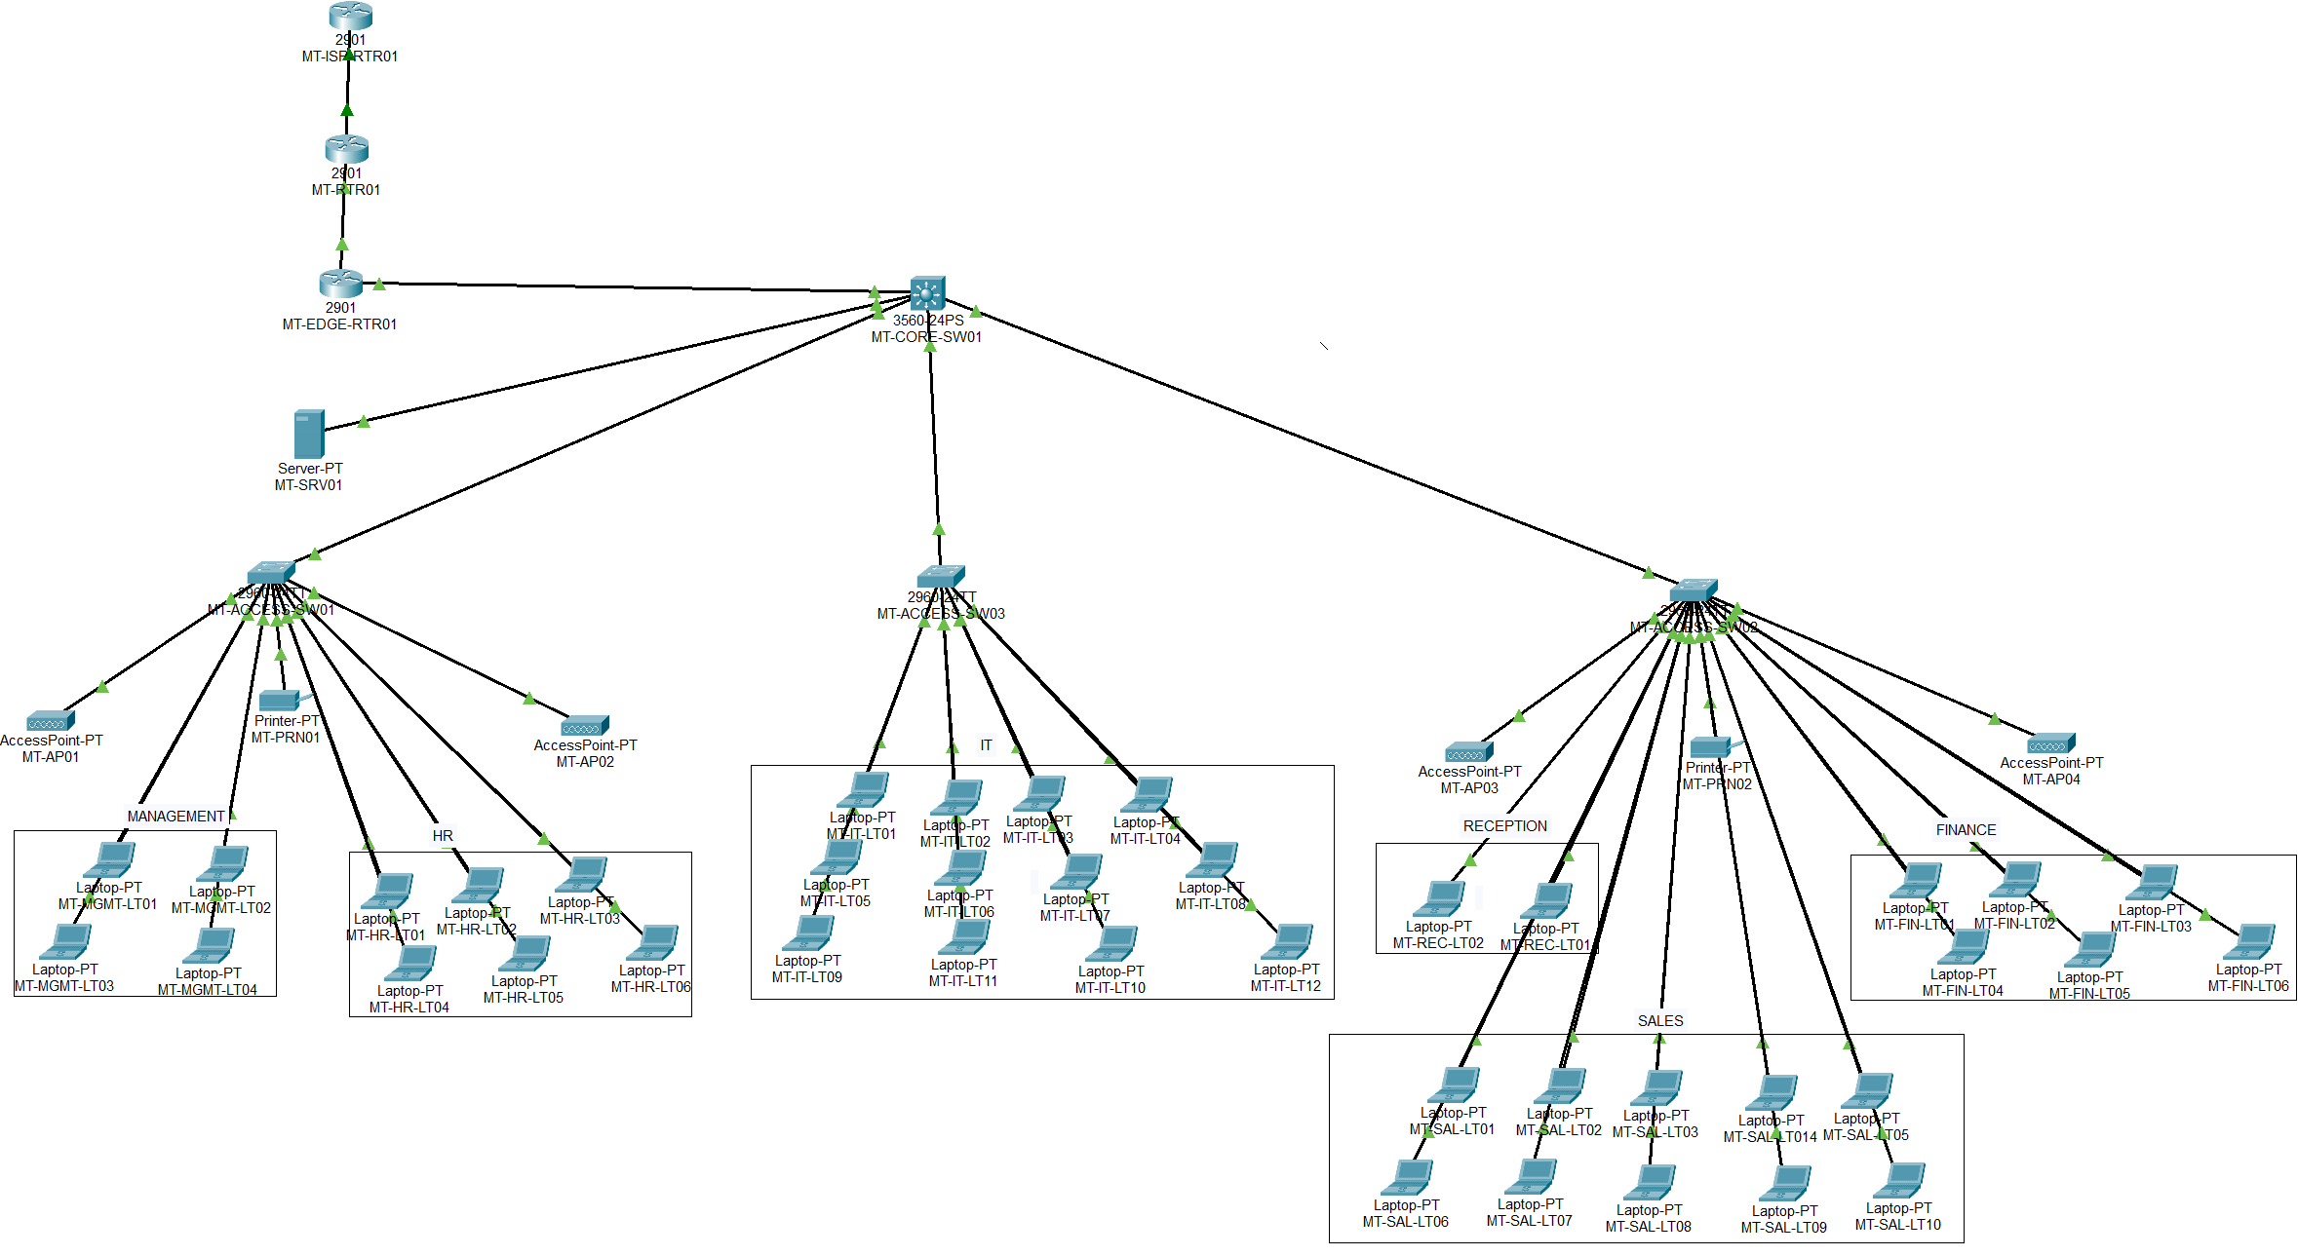

APPENDIX B

Final VLAN Configuration
Description
This appendix provides evidence that all VLANs were successfully created and assigned to the appropriate switch ports
Figure B.1: VLAN configuration on MT-ACCESS-SW01
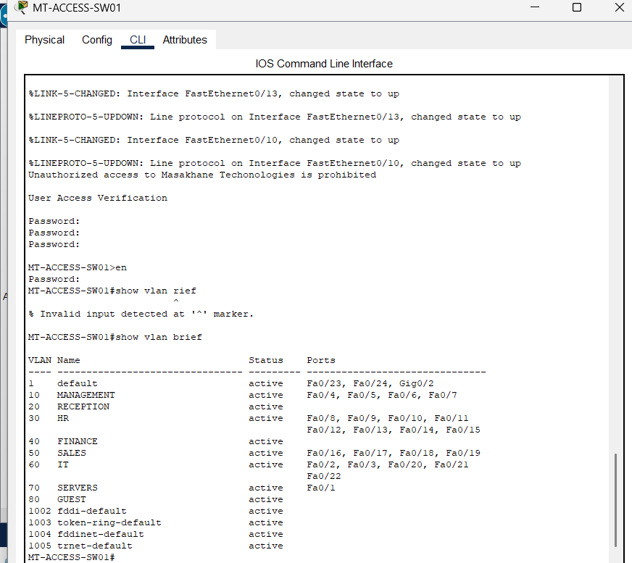

Figure B.2: VLAN configuration on MT-ACCESS-SW02
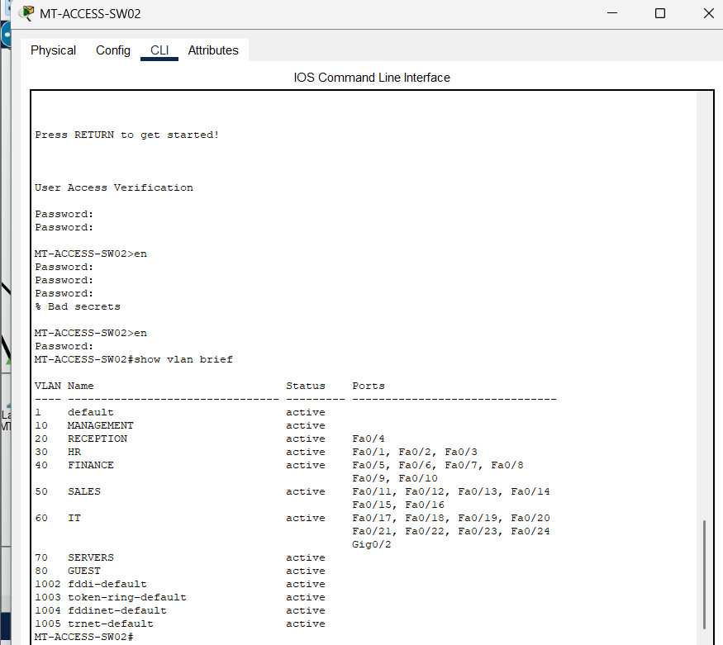
Figure B.3: VLAN configuration on MT-ACCESS-SW03
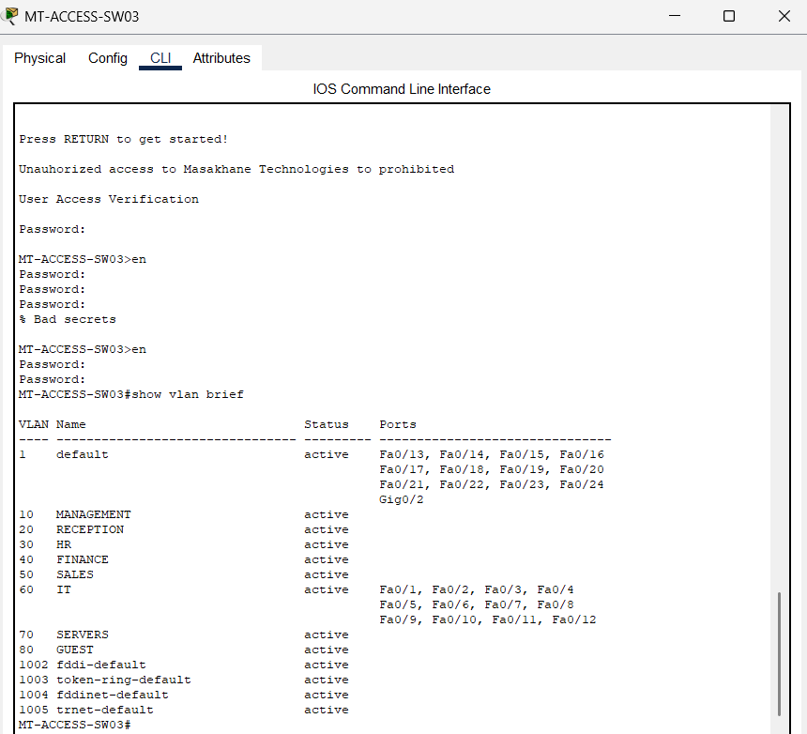

APPENDIX C
Trunk Configuration Verification
Description
This appendix verifies that trunk links were successfully configured between the Core Switch and the Access Switches. The trunk links allow multiple VLANs to traverse a single physical connection, enabling communication between departmental VLANs through the Layer 3 Core Switch
Figure C.1 Trunk configuration on MT-CORE-SW01
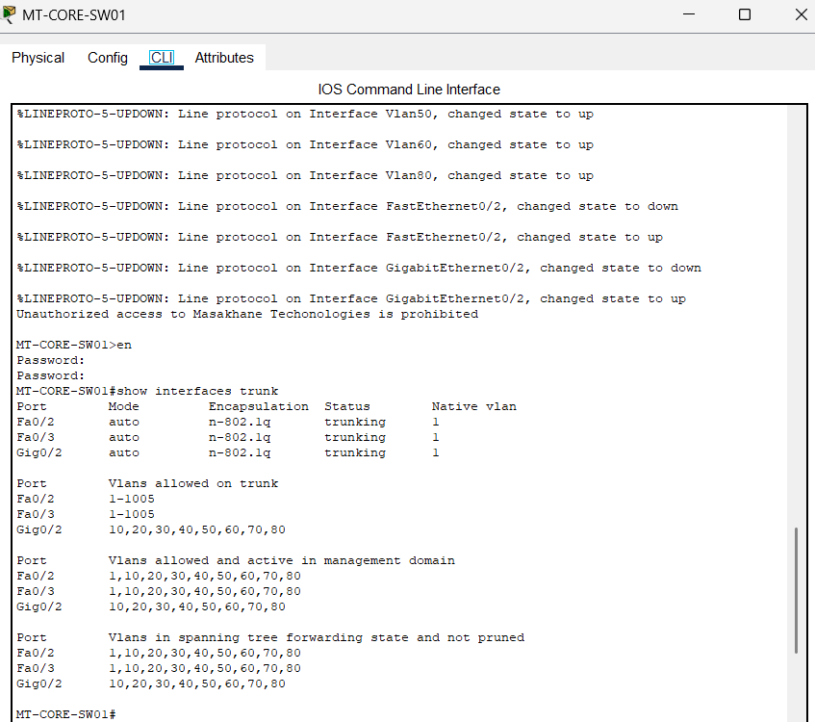

Figure C.2 Trunk configuration on MT-ACCESS-SW01
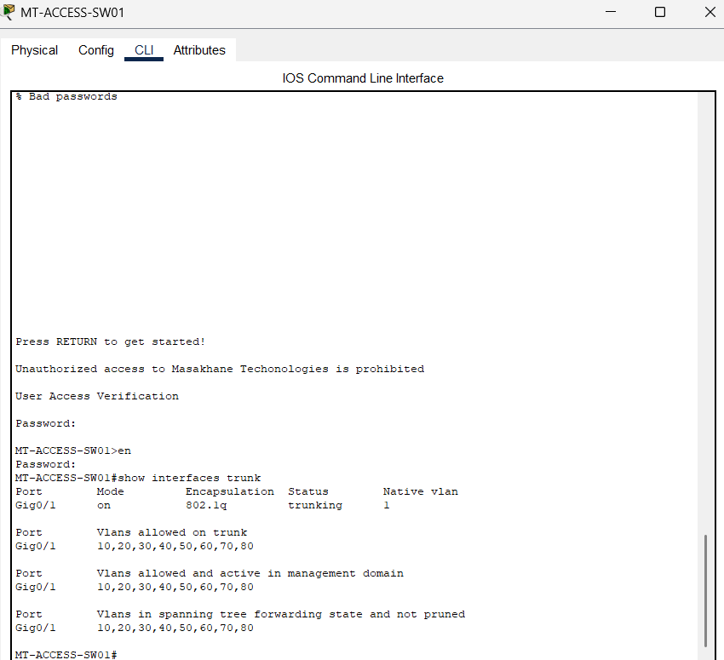

Figure C.3 Trunk configuration on MT-ACCESS-SW02
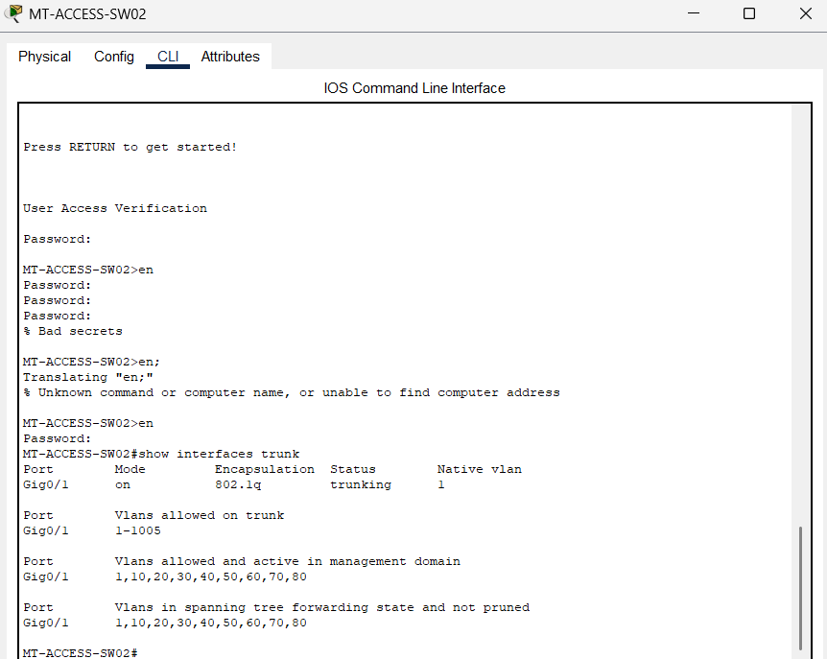

Figure C.4 Trunk configuration on MT-ACCESS-SW03
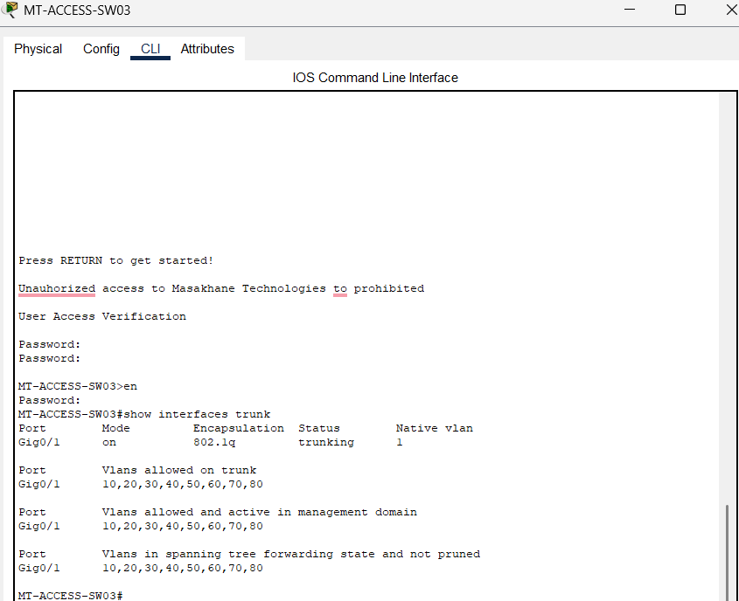

APPENDIX D

DHCP Configuration Verification
Description
This appendix verifies that the Dynamic Host Configuration Protocol (DHCP) service is functioning correctly. The screenshots below confirm that devices in each department successfully received IPv4 addresses, subnet masks, and default gateways automatically from the DHCP server.
Figure D.1 – Management Laptop DHCP Verification
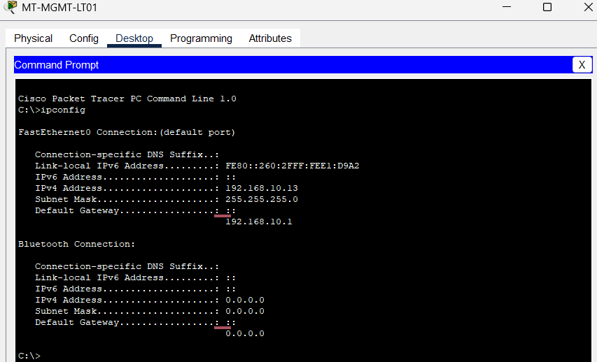

Figure D.2 – Reception Laptop DHCP Verification
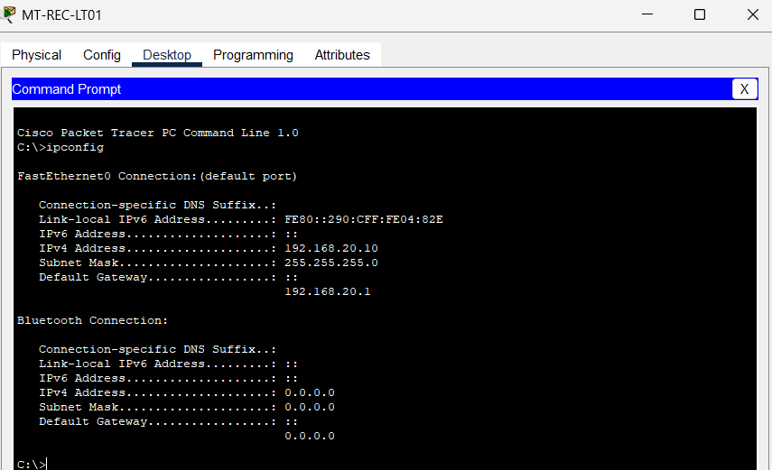

Figure D.3 – HR Laptop DHCP Verification
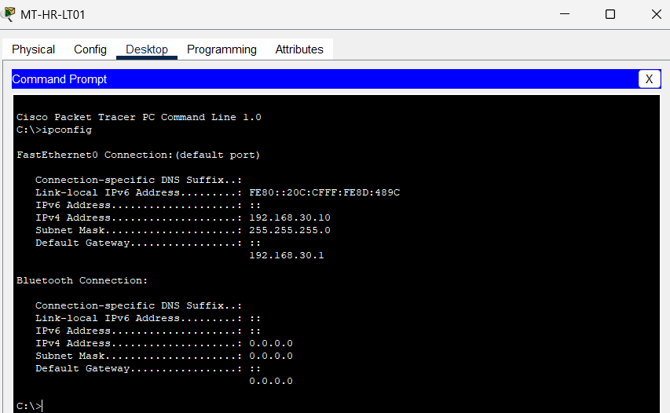

Figure D.4 – Finance Laptop DHCP Verification
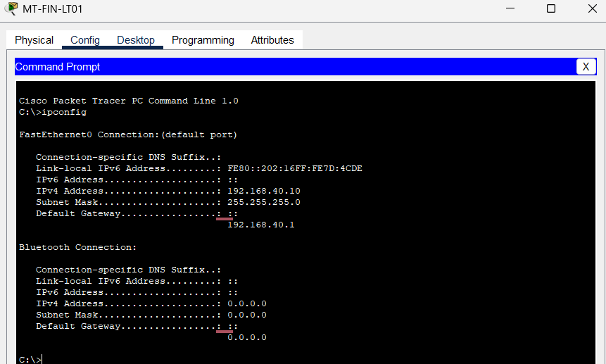

Figure D.5 – Sales Laptop DHCP Verification
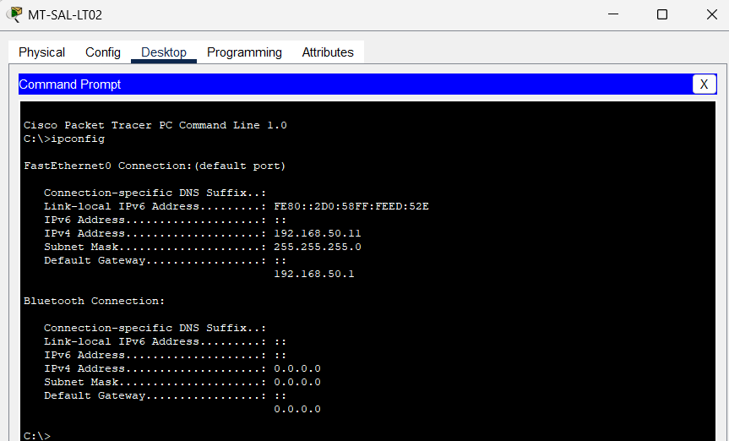

Figure D.6 – IT Laptop DHCP Verification
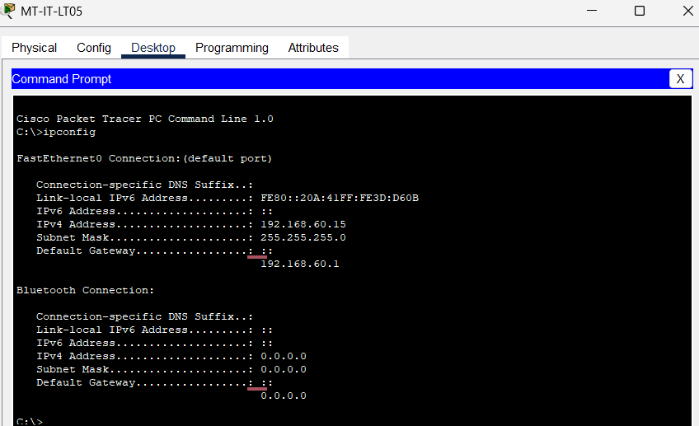

APPENDIX E
Connectivity Testing
Description
This appendix presents the connectivity tests performed after the network implementation. The successful ping results confirm that devices can communicate with their default gateways, the enterprise server, and network printers, demonstrating that inter-VLAN routing and network services are functioning correctly.
Figure E.1 – Management Laptop to Server
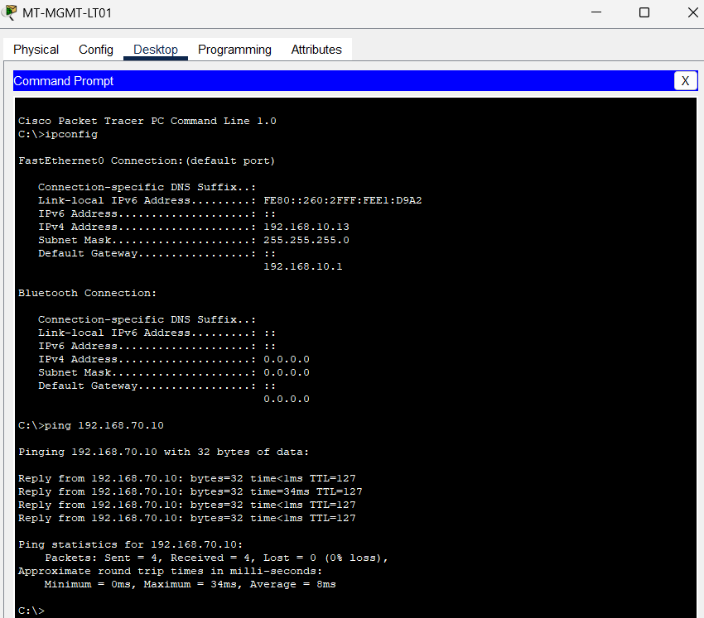

Figure E.2 – HR Laptop to HR Printer
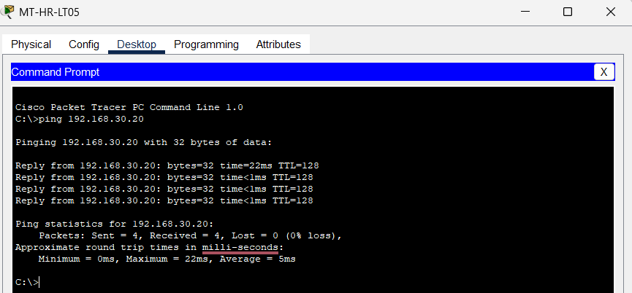
Figure E.3 – Finance Laptop to Finance Printer
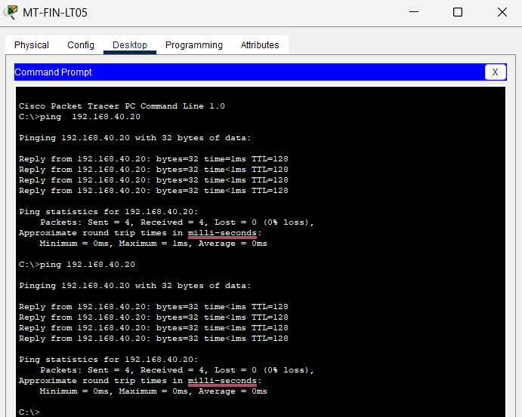

Figure E.4 – IT Laptop to Server
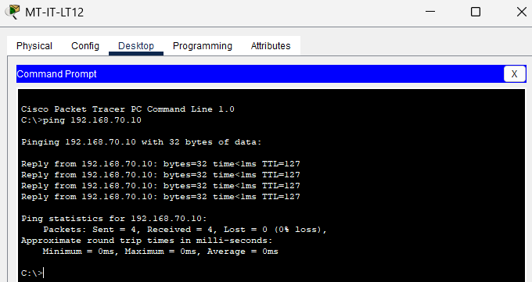

Figure E.5 – Reception Laptop to Server
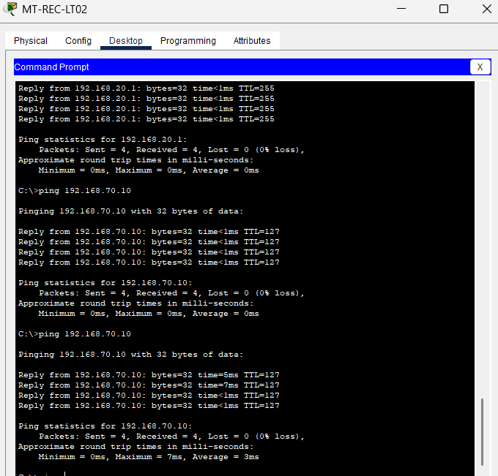

Appendix F
Static IP Address Verification
Description
This appendix verifies that all critical network devices requiring static IP addresses have been configured correctly. Static addressing ensures that essential services such as file sharing, printing, DHCP, and DNS remain consistently available throughout the enterprise network.
Figure F.1 – Enterprise Server
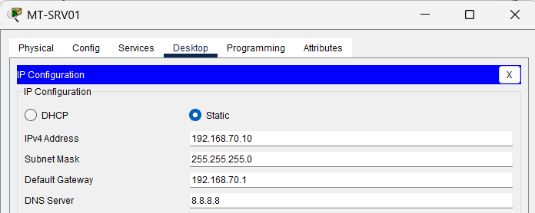

Figure F.2:
Network Printer (Located in HR Department) – Static IP Configuration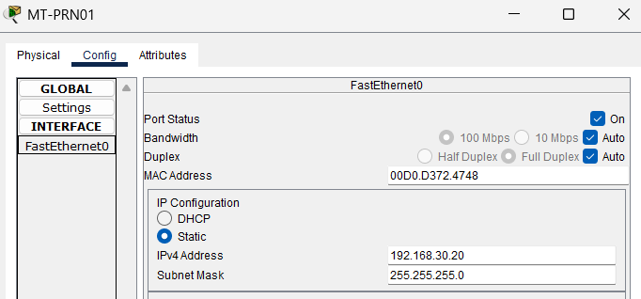

Figure F.3:
Network Printer (Located in Finance Department) – Static IP Configuration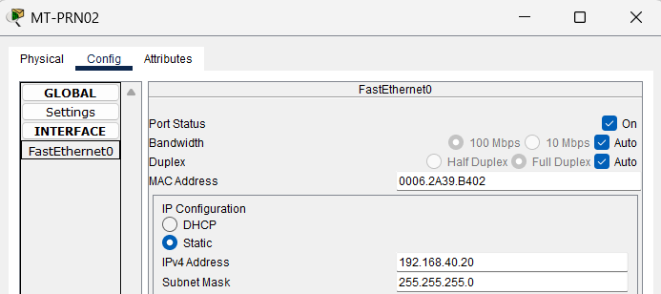

Appendix G
Inter-VLAN Routing Verification
Description
This appendix verifies that Inter-VLAN routing has been successfully configured on the Layer 3 Core Switch. Devices located in different VLANs are able to communicate with one another through the configured Switch Virtual Interfaces (SVIs), demonstrating successful routing between departmental networks.

Figure G.1: HR Laptop Communicating with Finance VLAN
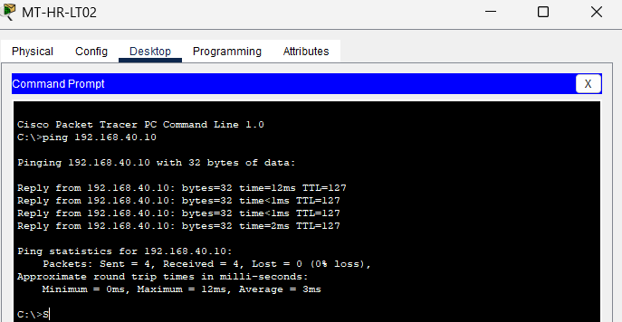

Figure G.2: Finance Laptop Communicating with IT VLAN


Figure G.3: IT Laptop Communicating with HR VLAN


Appendix H
Wireless Infrastructure Verification
Description
This appendix verifies that the wireless infrastructure has been successfully deployed within the enterprise network. Four wireless access points have been strategically installed to provide wireless coverage across the organisation. Although employee laptops are connected using wired Ethernet connections to maintain VLAN separation and network security, the wireless infrastructure remains available for future expansion and guest wireless access.
Figure H.1: Access Point 1 Installed in the Enterprise Network
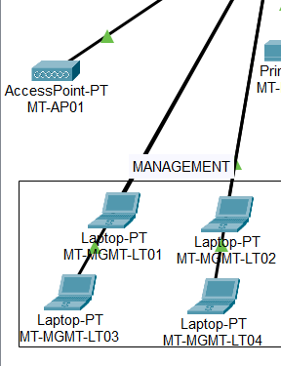
Figure H.2: Access Point 2 Installed in the Enterprise Network
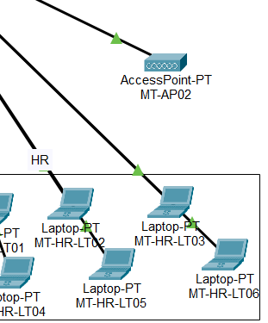

Figure H.3: Enterprise Wireless Infrastructure

Appendix I
Network Device Configuration Verification
Description
This appendix provides evidence that the major networking devices were configured successfully. The screenshots verify that the router, Layer 3 Core Switch, and Layer 2 Access Switches were assigned the correct hostnames and that the enterprise network devices were successfully configured according to the proposed network design.
Figure I.1 – Router Configuration

MT-RTR01#show running-config
Building configuration...

Current configuration : 1067 bytes
!
version 15.1
no service timestamps log datetime msec
no service timestamps debug datetime msec
service password-encryption
!
hostname MT-RTR01
!
!
!
enable secret 5 $1$mERr$gjNBR1u.Is9z7oaYvbvh//
!
!
!
!
!
!
ip cef
no ipv6 cef
!
!
!
!
license udi pid CISCO2901/K9 sn FTX1524NQ9W-
!
!
!
!
!
!
!
!
!
no ip domain-lookup
!
!
spanning-tree mode pvst
!
!
!
!
!
!
interface GigabitEthernet0/0
description Link-to-ISP
ip address 209.165.200.226 255.255.255.252
duplex auto
speed auto
!
interface GigabitEthernet0/1
description Link to MT-EDGE-RTR01
ip address 10.0.0.1 255.255.255.252
duplex auto
speed auto
!
interface Vlan1
no ip address
shutdown
!
ip classless
ip route 0.0.0.0 0.0.0.0 209.165.200.225
ip route 192.168.0.0 255.255.0.0 10.0.0.2
!
ip flow-export version 9
!
!
!
banner motd ^CUnauthorized access to Masakhane Technologies is prohibited

banner motd ^C
!
!
!
!
line con 0
password 7 0802455D0A1625464058
login
!
line aux 0
!
line vty 0 4
password 7 0802455D0A1625464058
login
line vty 5 15
password 7 0802455D0A1625464058
login
!
!
!
end

MT-RTR01#
Figure I.2 – Layer 3 Core Switch Configuration

MT-CORE-SW01#show running-config
Building configuration...

Current configuration : 2551 bytes
!
version 12.2(37)SE1
no service timestamps log datetime msec
no service timestamps debug datetime msec
service password-encryption
!
hostname MT-CORE-SW01
!
!
enable secret 5 $1$mERr$gjNBR1u.Is9z7oaYvbvh//
!
!
!
!
!
ip routing
!
!
!
!
!
!
!
!
!
!
!
!
!
no ip domain-lookup
!
!
spanning-tree mode pvst
!
!
!
!
!
!
interface FastEthernet0/1
description MT-SRV01
switchport access vlan 70
switchport mode access
!
interface FastEthernet0/2
!
interface FastEthernet0/3
!
interface FastEthernet0/4
!
interface FastEthernet0/5
!
interface FastEthernet0/6
!
interface FastEthernet0/7
!
interface FastEthernet0/8
!
interface FastEthernet0/9
!
interface FastEthernet0/10
!
interface FastEthernet0/11
!
interface FastEthernet0/12
!
interface FastEthernet0/13
!
interface FastEthernet0/14
!
interface FastEthernet0/15
!
interface FastEthernet0/16
!
interface FastEthernet0/17
!
interface FastEthernet0/18
!
interface FastEthernet0/19
!
interface FastEthernet0/20
!
interface FastEthernet0/21
!
interface FastEthernet0/22
!
interface FastEthernet0/23
!
interface FastEthernet0/24
!
interface GigabitEthernet0/1
no switchport
ip address 10.0.0.6 255.255.255.252
duplex auto
speed auto
!
interface GigabitEthernet0/2
description Trunk Link to MT-ACCESS-SW01
switchport trunk allowed vlan 10,20,30,40,50,60,70,80
!
interface Vlan1
no ip address
shutdown
!
interface Vlan10
mac-address 0030.f279.4001
ip address 192.168.10.1 255.255.255.0
ip helper-address 192.168.70.10
!
interface Vlan20
mac-address 0030.f279.4002
ip address 192.168.20.1 255.255.255.0
ip helper-address 192.168.70.10
!
interface Vlan30
mac-address 0030.f279.4003
ip address 192.168.30.1 255.255.255.0
ip helper-address 192.168.70.10
!
interface Vlan40
mac-address 0030.f279.4004
ip address 192.168.40.1 255.255.255.0
ip helper-address 192.168.70.10
!
interface Vlan50
mac-address 0030.f279.4005
ip address 192.168.50.1 255.255.255.0
ip helper-address 192.168.70.10
!
interface Vlan60
mac-address 0030.f279.4006
ip address 192.168.60.1 255.255.255.0
ip helper-address 192.168.70.10
!
interface Vlan70
mac-address 0030.f279.4007
ip address 192.168.70.1 255.255.255.0
!
interface Vlan80
mac-address 0030.f279.4008
ip address 192.168.80.1 255.255.255.0
ip helper-address 192.168.70.10
!
ip classless
ip route 0.0.0.0 0.0.0.0 10.0.0.5
!
ip flow-export version 9
!
!
!
banner motd ^CUnauthorized access to Masakhane Techonologies is prohibited^C
!
!
!
!
!
line con 0
password 7 0802455D0A1625464058
!
line aux 0
!
line vty 0 4
login
line vty 5 15
login
!
!
!
!
end

MT-CORE-SW01#

Figure I.3: Layer 2 Access Switch Configuration

MT-ACCESS-SW01#show running-config
Building configuration...

Current configuration : 3099 bytes
!
version 15.0
no service timestamps log datetime msec
no service timestamps debug datetime msec
service password-encryption
!
hostname MT-ACCESS-SW01
!
enable secret 5 $1$mERr$gjNBR1u.Is9z7oaYvbvh//
!
!
!
no ip domain-lookup
!
!
!
spanning-tree mode pvst
spanning-tree extend system-id
!
interface FastEthernet0/1
description MT-SRV01
switchport access vlan 70
switchport mode access
!
interface FastEthernet0/2
description Wireless_Access+Points
switchport access vlan 60
switchport mode access
!
interface FastEthernet0/3
description Wireless_Access+Points
switchport access vlan 60
switchport mode access
!
interface FastEthernet0/4
description MANAGEMENT-LAPTOPS
switchport access vlan 10
switchport mode access
!
interface FastEthernet0/5
description MANAGEMENT-LAPTOPS
switchport access vlan 10
switchport mode access
!
interface FastEthernet0/6
description MANAGEMENT-LAPTOPS
switchport access vlan 10
switchport mode access
!
interface FastEthernet0/7
description MANAGEMENT-LAPTOPS
switchport access vlan 10
switchport mode access
!
interface FastEthernet0/8
description HR-LAPTOPS
switchport access vlan 30
switchport mode access
!
interface FastEthernet0/9
description HR-LAPTOPS
switchport access vlan 30
switchport mode access
!
interface FastEthernet0/10
description HR-LAPTOPS
switchport access vlan 30
switchport mode access
!
interface FastEthernet0/11
description HR-LAPTOPS
switchport access vlan 30
switchport mode access
!
interface FastEthernet0/12
description HR-LAPTOPS
switchport access vlan 30
switchport mode access
!
interface FastEthernet0/13
description HR-LAPTOPS
switchport access vlan 30
switchport mode access
!
interface FastEthernet0/14
description HR-LAPTOPS
switchport access vlan 30
switchport mode access
!
interface FastEthernet0/15
description HR-LAPTOPS
switchport access vlan 30
switchport mode access
!
interface FastEthernet0/16
description SALES-LAPTOPS
switchport access vlan 50
switchport mode access
!
interface FastEthernet0/17
description SALES-LAPTOPS
switchport access vlan 50
switchport mode access
!
interface FastEthernet0/18
description SALES-LAPTOPS
switchport access vlan 50
switchport mode access
!
interface FastEthernet0/19
description SALES-LAPTOPS
switchport access vlan 50
switchport mode access
!
interface FastEthernet0/20
description IT-LAPTOPS
switchport access vlan 60
switchport mode access
!
interface FastEthernet0/21
description IT-LAPTOPS
switchport access vlan 60
switchport mode access
!
interface FastEthernet0/22
description IT-LAPTOPS
switchport access vlan 60
switchport mode access
!
interface FastEthernet0/23
!
interface FastEthernet0/24
!
interface GigabitEthernet0/1
description Uplink-to-MT-CORE-SW01
switchport trunk allowed vlan 10,20,30,40,50,60,70,80
switchport mode trunk
!
interface GigabitEthernet0/2
!
interface Vlan1
no ip address
shutdown
!
banner motd ^CUnauthorized access to Masakhane Techonologies is prohibited^C
!
!
!
line con 0
password 7 0802455D0A1625464058
login
!
line vty 0 4
login
line vty 5 15
login
!
!
!
!
end

MT-ACCESS-SW01#

Appendix J
Final Cisco Packet Tracer Implementation
Description
This appendix presents the completed Cisco Packet Tracer implementation of the proposed enterprise network for Masakhane Technologies (Pty) Ltd. The final topology includes the Internet connection, routers, Layer 3 Core Switch, Layer 2 Access Switches, enterprise server, departmental VLANs, wireless access points, network printers, and all end-user devices. The completed implementation demonstrates the successful deployment of the proposed enterprise network design and confirms that the network infrastructure supports secure communication, inter-VLAN routing, DHCP services, and future scalability.

Figure J.1: Final Cisco Packet Tracer Enterprise Network Implementation


